Xiao Long Bao
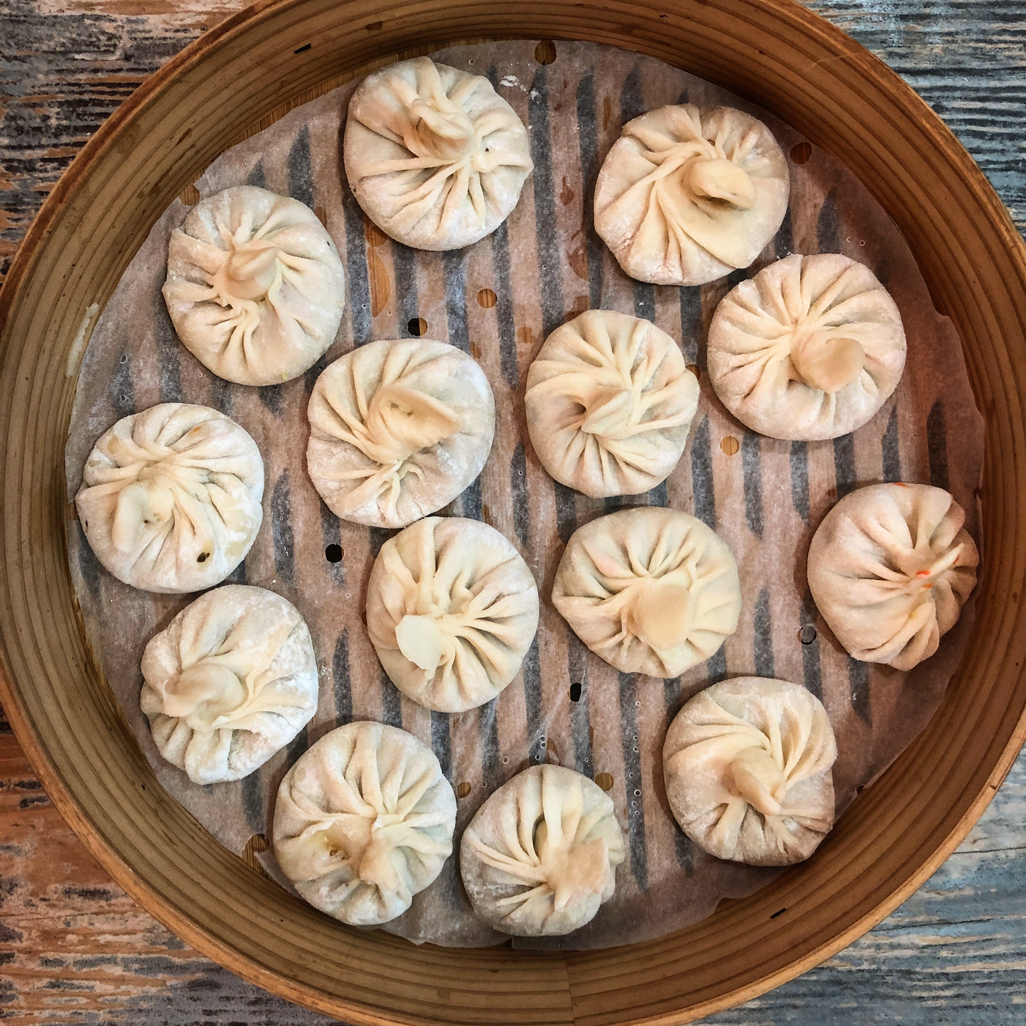

Youtube video: https://www.youtube.com/watch?v=Pm9mcDEOLiQ

Xiao Long Bao
Makes 25-30 Dumplings
Ingredients  FOR THE JELLY  400 g pork skin  a bunch of spring onion  6-7 slices ginger  1 tablespoon Shaoxing Chinese cooking wine  2 teaspoons sugar  1 teaspoon white pepper  1 teaspoon salt, or to taste  FOR THE PASTRY  2 cups or 250g unbleached all purpose flour or high protein flour  1/2 teaspoon salt  ¾ cup (180ml) hot water  SAUCE  1/8 cup spring onion bulbs  4 slices ginger  3 tablespoons water  FOR THE FILLING  200g ground fatty pork (with about 25% fat)  2-3 chopped spring onion  1/4 cup minced carrot  1/4 cup minced cabbage  1 teaspoon dark soy sauce  1 teaspoon white sugar  1 teaspoon sesame oil  1/2 teaspoon salt or to taste  1/4 teaspoon ground white pepper  FOR THE DIPPING SAUCE  some shredded fresh ginger  ¼ cup white vinegar or Ching Kiang black vinegar  1 tablespoon plus 1 teaspoon soy sauce  1 teaspoon chili oil (Lao Gan Ma), optional  Cooking Instructions Continued  MAKING THE FILLING (enough to make 25-30 dumplings)  - You can do this while the jelly is setting in the fridge.  - Use spring onion bulbs and ginger to make a sauce. Place them in a tall cup with 3 tablespoons water and blend well using a hand-blender until smooth. Strain the sauce into a bowl.  - Pour the sauce into the ground pork. Stir well.  - In a large mixing bowl place minced pork, spring onions, white sugar, dark soy sauce, sesame oil, salt and white pepper. Stir well in one direction for about 6 minutes until sticky.  - Add the vegetables into the meat, stir. You can switch it with other vegetables like water chestnuts or radish.  - Last step is to mix it well with the finely chopped minced jelly. Set it aside in the refrigerator.  CLOSE THE DUMPLINGS (This is the most important step to make your dumplings look great.)  - Cut each one log into roughly 3⁄4 inch pieces (about 10-12g each). Roll each piece into a ball. To roll the dumpling wrappers, dust your countertop lightly with flour.  - Keeping what you are not working with covered, roll one ball at a time into a thin disc roughly 8-10cm in diameter. Thin out the edges.  - Take a wrap and put enough meat so it’s almost full. I put a little bit more than a tablespoon.  - Lift one part of the edge and pinch it to make a pleat. Continue all the way around.  - At the end, pinch it together to close the dumpling. | Cooking Instructions  MAKING THE JELLY  - Blanch pork skin for 5 minutes to remove the bad smell.  - Clean it and remove the fat because you don’t want your soup to be too oily.  - Cut it into thin strips.  - Prepare a pot of water (1.8 L of water). Put in your pork skin. Bring it to a boil and then reduce heat to low-medium. Stew it for 1 hour.  - After 1 hour, add a bunch of spring onion, sliced ginger, Chinese cooking wine, sugar, white pepper, and salt. Keep stewing on low heat for another hour.  - Strain the broth into a container. After stewing, you should have about 400ml broth left. Put it in the fridge for at least 6 hours. Skin has a lot collagen, which dissolves in the water during stewing. When the temperature goes down, it turns into a jelly.  - Carefully mince the jelly using a pastry cutter or sharp knife. Make sure there are no big chunks. Try not to touch the pastry during chopping as it will start to soften. Use it immediately.  MAKE THE DUMPLING WRAPS  - Place the flour and salt in a medium bowl. Add the water, a little at a time, mixing constantly first with chopsticks and then with your hands until stiff dough comes together.  - Knead the dough until it is smooth, 8-10 min. (This kneading step is important, it helps develop tender dumpling wrappers)  - Put the kneaded dough into a clean bowl and cover it with a damp towel. Let the dough rest in a warm place for 30 minutes. Knead it again for a few minutes and let it rest again for another half an hour.  - Once rested, knead the dough again for 3-5 min and cut it into two, roughly even pieces.  - Roll each piece into a 1-inch diameter log (roughly 8 inches long). Let the dough logs rest on a lightly floured surface, covered with a damp tea towel, for 30 minutes while you prepare your filling.  Cooking Instructions Continued  FREEZING DUMPLINGS FOR LATER  - Arrange your filled, un-cooked dumplings in a single layer on a parchment-lined tray or baking sheet, freeze. Once your dumplings have frozen solid in about 2 hours, transfer them to an airtight container or Ziploc bag. Frozen dumplings keep well for up to 3 months.  - To steam, place frozen dumplings in a bamboo steamer lined with parchment paper (with holes) and steam for 8 minutes. Serve hot.  STEAM  (You do this as soon as possible after closing the dumpling)  - Put parchment paper (with holes for steam to escape) in a large bamboo steamer.  - Leave some space between the dumplings.  - In a large wok bring a few inches of water to a boil, then put the steamer in and let it steam it for 6 minutes on high heat.  - Serve hot  DIPPING SAUCE  - Mix together dipping sauce ingredients. Serve with steamed Xiao Long Bao

Notes: Normally, each dumpling should have 10-12 pleats in total. Don’t worry too much - it will take some practice to make them look perfect. Place folded dumplings on a tray lined with parchment paper (or dusted with flour) and cover with a tea towel while folding more dumplings.

To make quick and easy chicken stock jelly:
400ml chicken stock
2 tablespoons gelatin powder (use double the amount mentioned on your gelatin pack as you require thick jelly for the above recipe)

Bring chicken stock to a boil. Dissolve gelatin in a few tablespoons of hot stock. Pour it into the rest of the stock. Mix well using a whisk. Place it in a glass container, let it cool and refrigerate for about 6 hours until solid. Use as above.

**Tips on how to wash a new bamboo steamer here - Before using for the first time: Wash all pieces with hot soapy water, rinse well and then soak in hot water for 30 minutes. After soaking, steam all baskets and lid for about 30 minutes (while empty). Allow to fully air dry before storing. These are not dishwasher safe.

