Vegan Chinese Dumplings
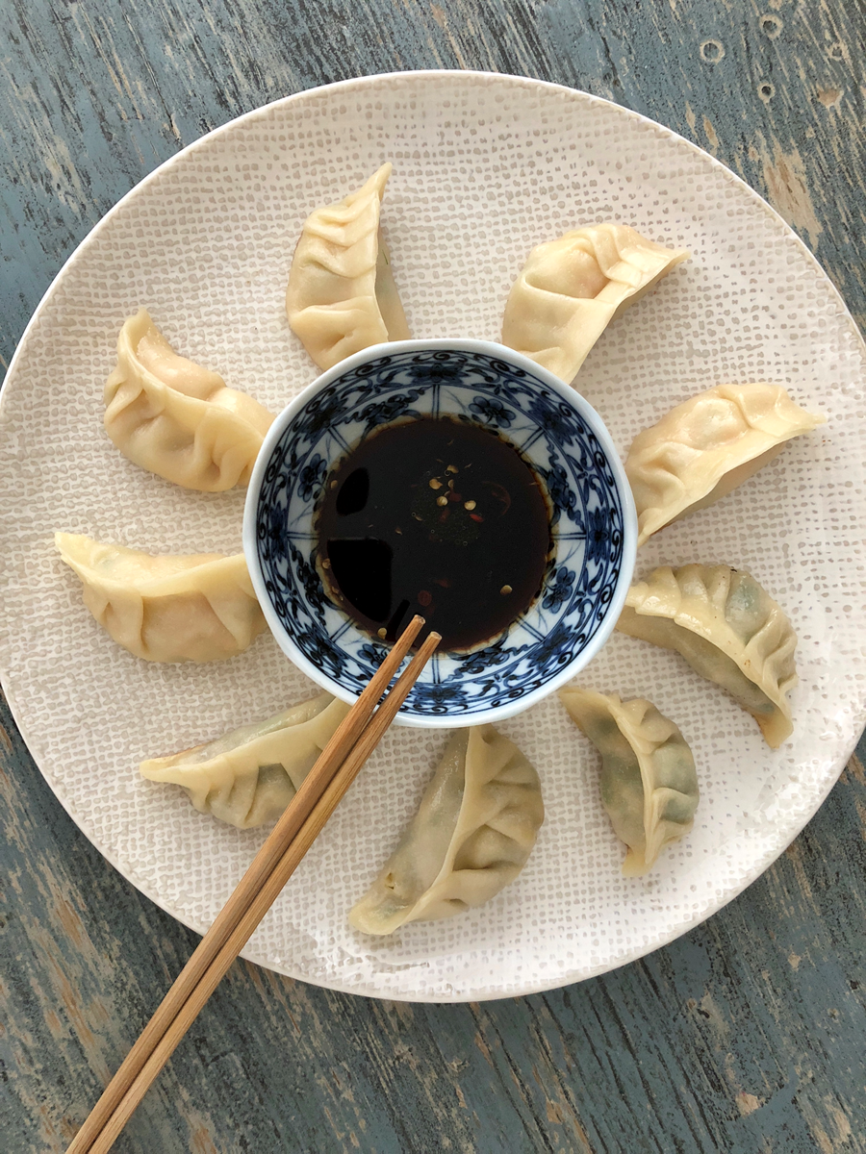

Dumpling Dough
Makes 30 Dumplings
Ingredients  2 cups or 250g unbleached all purpose flour  3⁄4 cup (180ml) tablespoons hot water  Special equipment:  Wok  Bamboo steamer  Parchment paper | Cooking Instructions  Making the Dough  - Place the flour in a medium bowl. Add water, little at a time, mixing constantly first with chopsticks, then with your hands until a stiff dough comes together.  - Knead the dough until it is smooth, 8-10 min. (This kneading step is important, it helps develop tender dumpling wrappers)  - Put the kneaded dough into a clean bowl and cover it with a damp towel. Let the dough rest in a warm place for 2 hours.  - Once rested, knead the dough again for 3-5 minutes and cut it into two, roughly even pieces.  - Roll each piece into a 2-cm diameter log (roughly 20cm long). Let the logs rest on a lightly floured surface, covered with a damp tea towel, for 30 minutes while you prepare your filling.  Rolling the Dumpling Wrappers  - Cut each log into roughly 1.5cm pieces (about 10-12g each). Dust sparingly with flour and toss. Press each ball into a disc shape (cut side down). To roll the dumpling wrappers, dust your countertop lightly with flour.  - Keeping what you are not working with covered, roll one disc at a time into a thin circle roughly 8cm in diameter (with the edges thinned out)  Filling and Sealing the Dumplings  - Holding the dumpling wrapper in one hand, place a tablespoon of filling in the center of the rolled out round of dough.  - If your wrapper seems dry, dip a finger into some water and lightly moisten the edge of the top half of the circular wrapper.  - Fold the wrapper in half around the filling and pinch the top of the half circle together.  - Continue sealing the edges, either by simply pressing or by using the ruffling technique. (Be sure to pinch the seam tightly to seal the filling inside.)

Dough Cooking Instructions- Continued  To Make Boiled Dumplings from Fresh or Frozen Dumplings  - Bring a pot of water to a boil.  - Add the dumplings and stir the water gently until the water starts to boil again, reduce heat to low.  - If your dumplings are fresh, cook them for 5 minutes (1 minute longer than it takes for them to float).  - If your dumplings are frozen, boil them for 7-8 minutes, until nicely swollen.  - Remove the dumplings from the water using a slotted spoon.  - Serve immediately with dipping sauce.  To Make Pot-stickers from Fresh or Frozen Dumplings  - Heat a tablespoon of oil in a non-stick skillet over medium-high heat.  - Once the oil is hot, place the pot-stickers into the skillet, with the seam side standing straight up, making sure that they are close but not touching.  - Let the pot-stickers sear for 1-2 minutes until the base is golden-brown.  - Add 3 tablespoons of water to the skillet. Cover the pan immediately and reduce the heat to low. Steam the dumplings until all the water has evaporated. The pot-stickers should look opaque and noodle-like, and the filling should be heated through. This will take 5 minutes from fresh or  7-8 minutes from frozen. | Dough Cooking Instructions- Continued  - Remove the lid and flip one pot-sticker over to see if the bottom side is nicely golden. If it isn’t, turn the heat to medium-high, and cook until the bottom sides are golden.  - Transfer the pot-stickers to a plate and serve immediately with dipping sauce.  Steaming Dumplings in a Bamboo Steamer  - Steaming is a much faster method as you only need to bring a few cups of water to a boil instead of an entire pot. Texturally, it'll also leave the skins a little stretchier and firmer. It does require the use of a bamboo steamer for your wok or pot. It's a worthwhile investment if you do any amount of Asian cooking.  - Pour a few cups of water in a large wok making sure there is at least 2 inches of water in the wok. Cover the wok and bring the water to a hard boil.  - Dumplings (especially frozen dumplings) will stick to the bamboo inside a steamer, so you need to line it first. If you've got some Napa cabbage in the fridge, the leaves make great steamer liners. Alternatively, you can use parchment paper with holes to make a breathable non-stick surface. Place your dumplings, then set the steamer on top of the wok full of boiling water. Steam the dumplings on full steam until cooked through, about 10-12 minutes, depending upon the size of the dumplings and the filling.  If Freezing the Dumplings For Later  - Arrange your filled, un-cooked dumplings in a single layer on a parchment lined platter or baking sheet, freeze. Once your dumplings have frozen solid in about 2 hours, transfer them to an air-tight container or Ziploc bag.
Notes: Dumplings will keep in the freezer for up to 3 months

Chinese Chive and Vermicelli Filling
30 dumplings
Ingredients  5 dried shiitake mushrooms, soaked overnight in water  250g Chinese chives  120g firm tofu (Tau Kwa), crumbled  1 bunch or 40g green bean vermicelli (LOOK FOR PASAR BRAND IN THE DRIED FOODS SECTION IN SUPERMARKETS )  1 tablespoon vegetable oil  1 tablespoon chopped ginger  3/4 teaspoon salt  1/2 teaspoon white pepper powder  1/4 teaspoon five-spice powder  1 teaspoon sesame oil  1 teaspoon light soy sauce  1 tablespoon corn starch mixed with 1 tablespoon water | Cooking Instructions  - Soak dried shitake mushrooms overnight in 2 cups of water.  - Thoroughly rinse the Chinese chives. Dry with a tea towel and finely chop them.  - Try to squeeze out as much water as possible from the mushrooms, discard stems. Finely chop mushroom heads and peeled ginger. Set them aside  - Soften the green bean vermicelli in warm water for about 5 minutes. Remove the excess water and finely chop the vermicelli. Set aside.  - In a large wok, heat vegetable oil on medium flame. Add ginger along the chives; stir-fry for about a minute.  - Next add, shitake mushrooms, tofu, and vermicelli. Add salt, white pepper, five-spice powder, sesame oil, and soy sauce to the stuffing mix.  - Thoroughly mix all the ingredients together. Add corn starch slurry if the stuffing appears to be watery. Transfer filling into a bowl.  - Cover and chill the mixed filling in the fridge for 30 minutes before making dumplings

Spinach and Tofu Filling
30 Dumplings

Ingredients  250g Chinese spinach, discard roots and most part of the stems and rinse well  4 large dried shitake mushrooms, soak overnight in water  1/4 teaspoon salt  1/4 teaspoon ground white pepper  3/4 teaspoon sugar  1 1/2 tablespoons light (regular) soy sauce  1 tablespoon sesame oil  1 tablespoons vegetable oil  1 tablespoon finely minced fresh ginger  1/3 cup finely chopped carrot  90g firm tofu (Tau Kwa), finely chopped  2 teaspoons cornstarch dissolved in 1 tablespoon water  1/2 cup chopped Chinese chives or scallions (white and green parts) | Cooking Instructions  - To make the filling, bring about 1.5 L water to a boil, Add spinach and let it wilt for about 60 seconds, drain, rinse with cold water, and drain again to retain color. To remove excess moisture, squeeze the spinach in your hands over the sink. When you are done, there should be about 1/2 cup firmly packed spinach. Chop coarsely on a chopping board, set aside.  - In a bowl, rinse and soak dried shitake mushrooms overnight in 2 cups water. Once soaked, reserve soaking liquid, squeeze excess water out from mushrooms and stem them, then chop finely.  - Combine 1/4 cup of the reserved mushroom soaking liquid, salt, white pepper, sugar, soy sauce, and sesame oil. Stir to dissolve the sugar. Set this flavoring sauce aside.  - In a wok or large skillet, heat vegetable oil over medium heat. Add the ginger and stir-fry for about 30 seconds, until aromatic. Add the spinach, carrot, mushrooms, and tofu. Stir to combine and then pour in the flavoring sauce. At first, all the liquid will seem to have been absorbed, but after 2 minutes, there will be a little bubbling liquid in the skillet. At that point, give the cornstarch mixture a final stir and stir it into the filling. When the mixture thickens, turn off the heat and add the Chinese chives. Transfer to a bowl and set aside to cool completely before assembling the dumplings. You should have about 2 cups of filling. (The filling can be prepared 1 day in advance and refrigerated. Bring it to room temperature before assembling the dumplings.)

Dipping Sauce

Ingredients  1/3 cup (80 ml) soy sauce  2 ½ tablespoons rice vinegar  1 teaspoon chili oil or 1 finely chopped red chili padi  1 tablespoon ginger, cut into matchsticks | Cooking Instructions  - In a small bowl mix all ingredients together. Taste and adjust flavor as needed.

