Chicken Tikka Masala
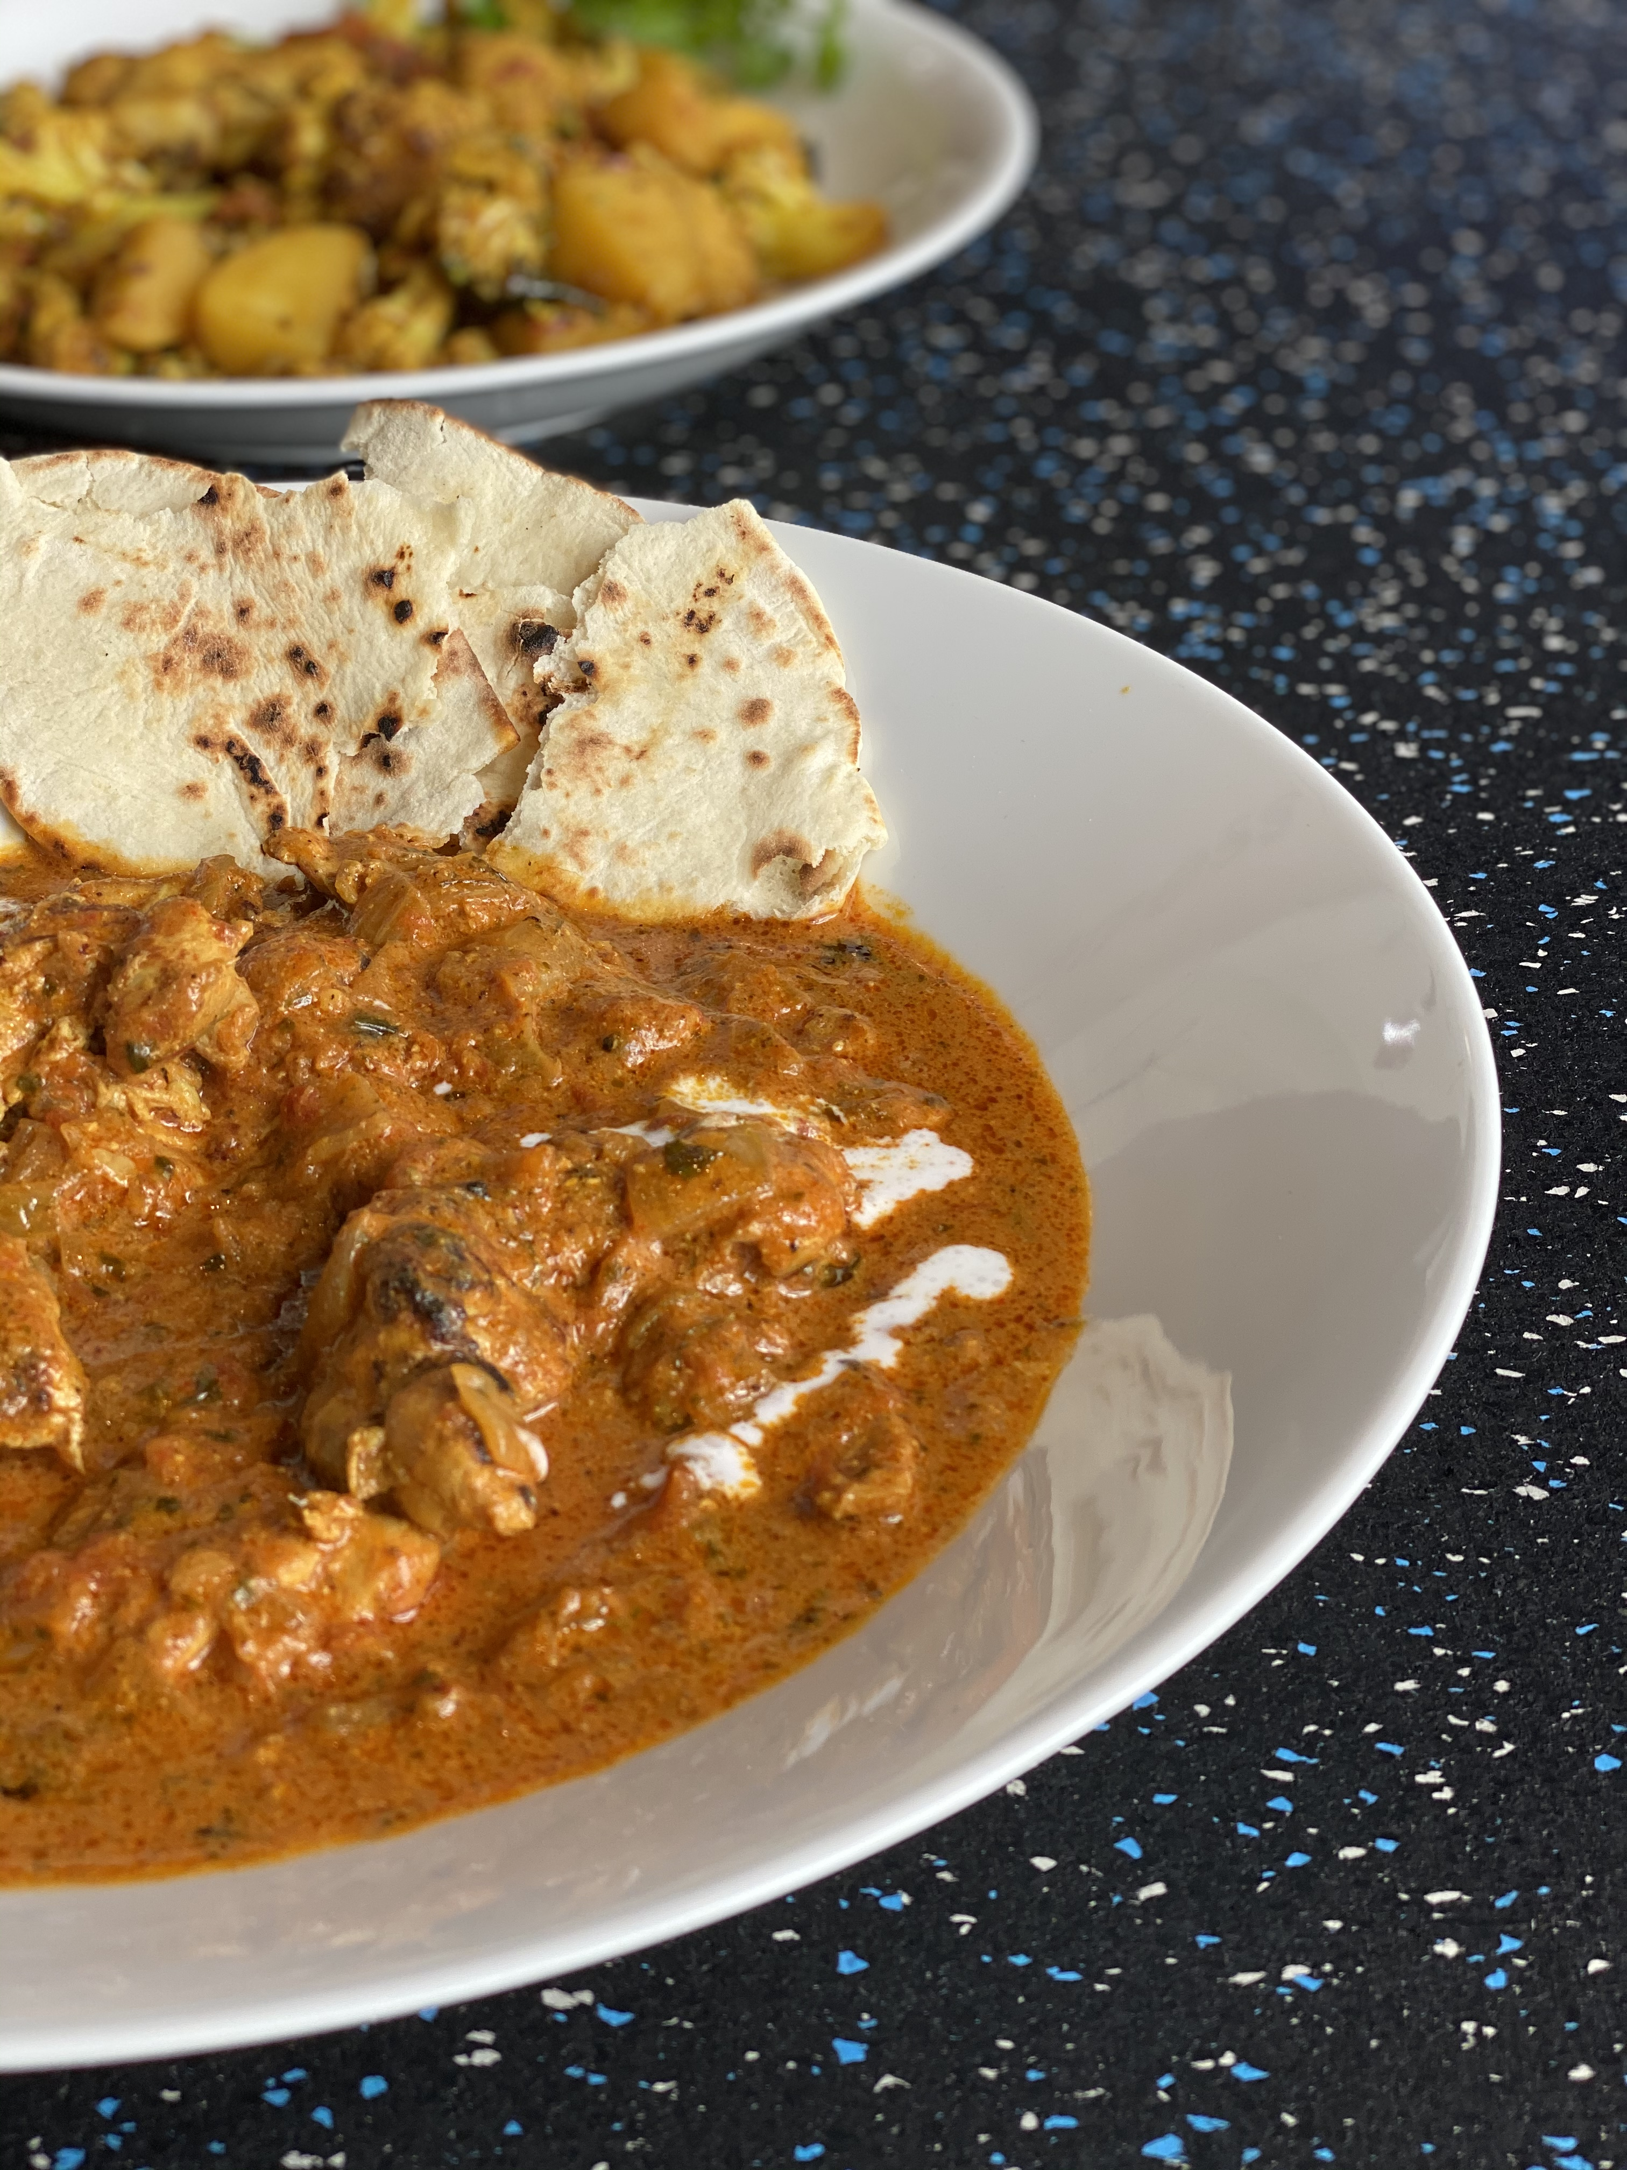

Chicken Tikka Masala
-Serves 6
Please have all ingredients prepped and ready prior to this class, including soaking lentils for at least 1 hour (links to order ingredients below)
Ingredients  For Chicken Tikka:  ​1 kg boneless, skinless chicken thighs, chopped into 1-inch wide strips  1 tablespoon lemon juice  1 teaspoon salt  1/2 cup plain unsweetened Greek yogurt  1 tablespoon finely minced garlic  1 tablespoon finely minced ginger  1-2 fresh bird’s eye chilies, minced  1/2 teaspoon ground turmeric powder  3/4 teaspoon cumin powder  3/4 teaspoon garam masala powder  1/4 teaspoon red chili powder, or to taste  1-2 tablespoons melted butter or ghee or coconut oil, for brushing  For Sauce:  3 tablespoons coconut oil or ghee  200g red onion, chopped into large cubes  2 cloves garlic, finely chopped  1 tablespoon finely chopped ginger  1 fresh bird’s eye chili, finely chopped  400g canned Italian tomatoes, chopped  1 tablespoon coriander powder  1/4 teaspoon turmeric powder  1/4 teaspoon or to taste red chili powder  1 teaspoon salt  3/4 teaspoon garam masala powder  2-3 tablespoons kasuri methi (dried fenugreek leaves), crushed and rinsed in a sieve  1/2 cup (120ml) Marigold King of Kings full cream evaporated milk  1 tablespoon butter, for garnish – optional  Steamed rice, to serve | Cooking Instructions  For Chicken Tikka  ​Sprinkle salt and lemon juice all over chicken, mix well and let it sit for 15 minutes. Put chicken in a large bowl. Add yogurt, spices and all other ingredients above except butter/oil. Rub the marinade well on chicken pieces and marinate for at least 3-4 hours in the refrigerator, preferably overnight.  Pan-frying Chicken  - Bring the chicken back to room temperature by leaving it out on your countertop for at least 30 minutes before cooking. Heat a tablespoon of butter/ghee/coconut oil on medium heat in a large non-stick frying pan or seasoned cast iron pan.  - Fry chicken pieces a few at a time until seared and slightly charred on both sides. This may take about 2-3 minutes on each side (4-6 minutes altogether). Drain chicken and set aside. To cook chicken fully, toss it for 2 extra minutes in the pan before serving.  - Repeat steps 1 and 2 until all your chicken is cooked. Set aside any leftover chicken marinade to use in the sauce.  Making Sauce:  - Heat oil/ghee in a large saucepan on medium heat; add onions, ginger, garlic, fresh chili and fry until onions turn slightly golden brown. Add any leftover chicken marinade.  - Add tomatoes and mix well. Using a hand blender, puree sauce until smooth. You can choose to keep the sauce chunky and not blend it at all.  - Add turmeric powder, chili powder, coriander powder and salt. Mix well and bring it to a boil.  - Add chicken to the sauce along with any reserve liquid from the frying pan and mix well. Bring to the boil.  - Cook for about 10 minutes on medium flame until spices start releasing their oils and tomatoes are pulpy. Add 1 cup water, stir well and bring to the boil.  - Reduce heat to low flame, cover and cook for about 10-20 minutes depending on the size of your chicken pieces or until chicken is fully cooked.  - Finally add garam masala powder, kasuri methi leaves, and evaporated milk. Stir well.  - Garnish with butter. Serve hot with steamed rice.

Masoor Dal Makhani
-serves 6
Please have all ingredients prepped and ready prior to this class, including soaking lentils for at least 1 hour (links to order ingredients below)
Ingredients  1 cup (240ml) masoor sabut (whole red lentils), rinse and soak in 2.5 cups water for at least one hour  3 tablespoons oil/ghee  1 tablespoon cumin seeds  125g onion, finely chopped  3 cloves garlic, finely chopped  1 tablespoon chopped ginger  1 fresh green chili padi, finely chopped  1/2 teaspoon turmeric powder  1/4 teaspoon chilli powder, optional  1 tablespoon coriander powder  1.5 teaspoons salt, or to taste  400g ripe fresh tomatoes, chopped  1 teaspoon garam masala  1 tablespoon lemon juice  2-3 tablespoons kasuri methi (dried fenugreek leaves)  1/2 cup (120ml) Marigold King of Kings full cream evaporated milk  1 tablespoon butter, optional | Instructions  - Rinse masoor sabut lentils under running water and soak them for about an hour in 2.5 cups of water.  - Place lentils and water in a saucepan. Bring to the boil, reduce heat, cover partially and cook for about 20 minutes until beans are slightly soft.  - Add oil/ghee in a large heavy base saucepan. Drop in cumin seeds, let seeds splutter. Add onion, ginger, garlic, fresh chili pad and stir well.  - Fry onion until slightly golden brown, then add turmeric, chili powder, coriander powder and salt, stir.  - Next, add tomatoes and stir fry for about 5 minutes until oil surfaces.  - Add cooked beans along with any leftover bean stock followed by additional 1.5 cups of water. Bring to the boil. Lower heat, cover and let it simmer for about 15-20 minutes.  - Finally, add garam masala powder, kasuri methi, lemon juice, butter and evaporated milk, stir well. Serve hot with steamed rice.

Equipment needed:
Hand blender (stick blender)
Large bowl, for marinating chicken
Heavy base non-stick frying pan, for frying chicken
2 Heavy base saucepans, for cooking Tikka masala sauce & Dal makhani
1 small saucepan, to soak & cook lentils
Tongs, for flipping chicken
Spoons and spatulas
Chopping board and knives

LINKS FOR SPICES (NO AFFILIATION – these links are for guidance purposes only)
Please keep all spices refrigerated and store kasuri methi in the freezer. Please see links below and email us on info@communekitchen.com if you have any questions.
Indian Spicebox (This box contains all spices except cumin powder. You can even buy the spices separately in individual containers – see links below)
https://www.lazada.sg/catalog/?spm=a2o42.pdp.red-mart-search.2.5ca24961vhWDt8&q=indian%20spicebox&_keyori=ss&from=suggest_normal&m=redmart&sugg=indian%20spicebox_1_1
https://indian-spicebox.com/shop-online/
Cumin seeds
https://indian-spicebox.com/shop-online/cumin-seeds-silver/
Chili powder
https://indian-spicebox.com/shop-online/red-chili-powder-silver/
Turmeric
https://indian-spicebox.com/shop-online/ground-turmeric-silver/
Coriander powder
https://indian-spicebox.com/shop-online/coriander-seeds-silver/
Cumin Powder
https://www.lazada.sg/products/the-urban-spice-shop-organic-cumin-powder-i989190738-s3586206262.html?spm=a2o42.searchlist.list.7.7da366149ov9xn&search=1
Garam masala
https://indian-spicebox.com/shop-online/garam-masala-silver/
Kasuri methi
https://www.lazada.sg/products/mdh-kasuri-methi-25gm-i303736071-s537390877.html?spm=a2o42.redmart_search.list.9.6b985baa9i3XTi&search=1

Ghee (optional - coconut or vegetable oil can be used instead)
https://www.lazada.sg/products/qbb-ghee-by-sri-ambikas-i303092558-s536390127.html?spm=a2o42.lazmart_search.list.8.29e5f9f4WNJc6o&search=1
Masoor Sabut (Whole red lentils)
https://www.lazada.sg/products/just-organik-organic-masoor-wholesabut-i304280062-s538462669.html?spm=a2o42.lazmart_search.list.1.645d73793VJayX&search=1
Marigold full cream evaporated milk
https://www.lazada.sg/products/marigold-king-of-kings-full-cream-evaporated-milk-i301166044-s527236758.html?spm=a2o42.lazmart_search.list.2.3b1d5824cCUBi2&search=1

Saffron
https://www.lazada.sg/products/pure-organic-iranian-saffron-i318836345-s617302637.html?spm=a2o42.lazmart_search.list.2.37c237d6MTj2ew&search=1

