_{Tacos}
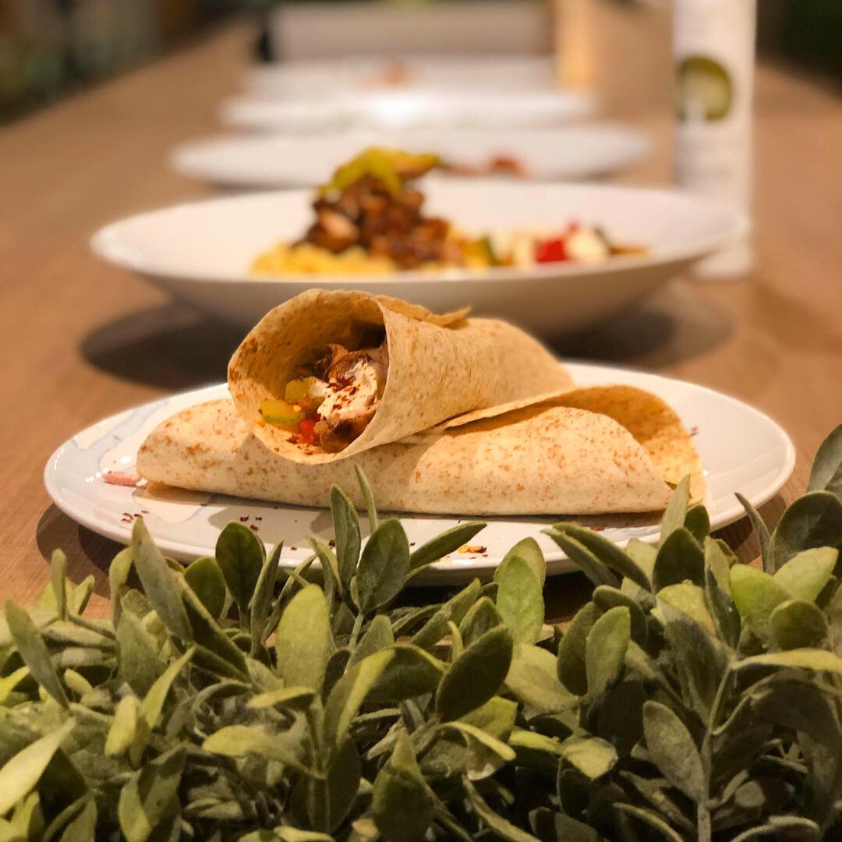

Buttermilk Chicken
Serves 3-4

Ingredients  150ml buttermilk  2 tablespoons smoked paprika  1 teaspoon cayenne pepper  2 tablespoons maple syrup  1/2 teaspoon salt  1/3 teaspoon freshly ground pepper  450g chicken thigh fillets, cut into 1cm wide strips  120g soy flour or rice flour or plain (all-purpose) flour  1 teaspoon cayenne pepper  finely grated zest of ½ lemon  vegetable oil, for deep-frying or olive oil, for shallow-frying | Cooking Instructions  - Make the marinade by combining the buttermilk with the spices and maple syrup in a glass or ceramic bowl. Season with salt and pepper, then add the chicken and mix well. Refrigerate at room temperature for one hour or overnight for best flavor. Bring back to room temperature by placing it on the counter top for about 30 minutes before cooking.  - When you’re ready to cook the chicken, combine the flour with the cayenne and lemon zest in a shallow bowl, then season generously with salt and pepper.  - Pour the vegetable oil into a deep-fryer or large heavy-based saucepan and heat to 190°C (375°F). If you don’t have a thermometer, test the temperature by adding a cube of bread: it should sizzle and turn golden brown in 10 seconds.  - Working in small batches, remove the chicken from the marinade, trying to keep as much marinade clinging to the meat as possible, then put it straight into the flour mixture, coating it well on all sides.  - Carefully add to the hot oil and deep-fry for 3-4 until golden brown. Using a slotted spoon, remove the chicken from the oil and drain on paper towel.  Note: To make pan-fried chicken, cook chicken in batches in 1-2 tablespoons of olive oil, for 3-4 minutes on each side until cooked slightly charred all over and cooked through.

Fish Tacos
Serves 3-4

Ingredients  3 tablespoons olive oil  1/2 teaspoon cayenne pepper, or to taste  1 1/2 teaspoons dried oregano  1 teaspoon ground cumin  1/2 teaspoon garlic powder  1/4 cup coriander leaves, finely chopped  1 green jalapeño, finely chopped  1 teaspoon sea salt  1/2 teaspoon ground black pepper  450g flaky white fish fillets, chopped into 1-2 inch wide strips (threadfin, snapper, cod, sole, baramundi)  1/2 cup rice flour or plain flour, for dusting | Cooking Instructions  - In a large bowl, mix together olive oil, cayenne pepper, oregano, cumin, garlic, chopped coriander, Jalapeno, salt and pepper. Add fish, mix well, and set aside for 15 minutes.  - Cover fish in flour and dust excess flour. Pan-fry or deep-fry fish for 2-3 minutes on each side until cooked through. Cooking time may vary slightly depending on the width of the fish.
Plantains
Serves 3-4

Ingredients  Frijoles Refritos (Refried Beans)  420g can black beans (if unsalted, add more salt)  1/2 teaspoon ground cumin  1 pinch cayenne (or chili powder)  2 tablespoons vegetable oil or lard  150g onion, finely chopped  Plantains  2 very ripe large plantains* (peeled and cut on an angle into 1/4-inch slices)  1 tablespoon coconut oil  2 tablespoon coconut sugar  1 teaspoon ground cumin  1/2 teaspoon ground cinnamon  1/4 teaspoon sea salt (plus more to taste)  1/8 teaspoon cayenne pepper  Coconut oil, for frying | Cooking Instructions  MAKING REFRIED BEANS  - Add black beans to a small saucepan over medium heat and add spices. Once it reaches a low boil, turn heat to low and simmer for a few minutes before blending into a smooth paste. Add water if necessary (the consistency should be smooth and silky like thick pancake batter)  - Heat oil in a cast-iron skillet. Add onion and fry for 3-4 minutes. Once the onions are translucent, pour the bean paste into the cast-iron skillet with the onions. Stir well with a wooden spoon to combine. The mixture should be silky smooth and not too thick—it should coat the back of a spoon but still drip off. Taste the beans for seasoning and add more salt if necessary. Set aside.  FRYING PLANTAINS  - Peel and chop plantains and heat a large metal or cast iron skillet over medium heat. Add plantains to a mixing bowl and toss with spices.  - Once pan is hot, add coconut oil and plantains and spread into a single layer. Sauté on one side for 2-3 minutes, then flip and sauté on the other side for 2-3 minutes more. Turn down heat if browning too quickly. You're going for a caramelized effect. Serve hot with tacos, black beans, and salsa.

Tortillas
Makes 10-12 pieces

Ingredients  2 cups Masa Harina  2 cups hot water, plus more if necessary  1/2 teaspoon sea salt  Masa or rice flour, for dusting – if necessary | Cooking Instructions  - In a large bowl, mix together masa harina and salt. Pour almost 2 cups of hot water (leaving a tablespoons water behind) into the dough and mix using a spoon until you get a ball. Use your hand to knead the dough for a few minutes until smooth. The dough should be soft and springy like fresh play dough. If dry, slowly add more water and continue kneading until you get the right texture. Bob’s Red Mill Masa flour does take up about 2 cups of water. Cover the bowl with a damp cloth and let it rest for about an hour.  - Heat a griddle or heavy frying pan on medium flame for about 5 minutes. In the meantime, check the texture of the dough; if dry, add 1-2 teaspoons of water and knead until smooth and pliable. Split the dough into golf ball sized portions and make smooth round balls by rolling them in between your palms. Cover the balls with a damp cloth while rolling one ball at a time.  - If using the tortilla press, place one ball in the centre of the press (lined with plastic wrap or baking paper on both sides) and press until flat. Alternatively, place the dough ball in-between two large ziplock bags (or squares of parchment) and roll into thin circles using a rolling pin.  - Gently remove the flattened tortilla and cook on the pan for about 30-40 seconds, until brown spots appear.  - Flip the tortilla over and cook on the other side for 30-40 seconds. You may use a rubber spatula to gently press on the tortilla so it puffs up.  - Remove the tortilla from the pan and place it covered in a tea towel, cover.  - Use the rest of your dough to make tortillas the same way and stack them covered in the tea towel. This is where the magic happens. Your tortillas may look dry initially but when you let them rest together in their own steam, they magically turn into soft, golden flatbreads that will make you hate pre-packaged tortillas forever!
Note: Please note that Masa Harina is nixtamalized corn which means the corn has been treated with lime. The process make it easier to grind, increases its nutritional value and makes it more delicious. Plain corn flour should not be used to make corn tortillas.

Guacamole
Serves 3-4

Ingredients  1 large ripe avocado  2 tablespoons sour cream or greek yogurt  2 tablespoons lemon juice  1/2 teaspoon ground cumin  1/4 teaspoon paprika  2 tablespoons chopped coriander  2 tablespoons chopped onion  4 tablespoons chopped cherry tomatoes | Cooking Instructions  - Mash avocado flesh using a fork. Add all other ingredients, mix well. Serve chilled.  - To check ripeness, pick an avocado with dark skin and press it gently using your thumb. It should feel soft to the touch. Don’t pick one that is too soft.

Charred Tomato Salsa (Salsa Tatemada)
Serves 4

Ingredients  500g vine-ripened tomatoes, , cut into quarters in case of large tomatoes  1 large red onion  6 cloves garlic, peeled  2-3 jalapeño peppers (use less for milder salsa)  1/4 cup olive oil  1 teaspoon sea-salt  1 teaspoon cumin  1/4 cup cilantro leaves  Juice from 1 lemon, plus more if needed | Cooking Instructions  - Preheat the broiler and set an oven rack about 5 inches beneath the heating element. Line a rimmed baking sheet with aluminum foil.  - Place the tomatoes, onions, garlic, jalapeno peppers, and olive oil directly on the prepared baking sheet and toss with your hands. Broil until softened and charred, 10-15 minutes.  - Transfer the vegetables and juices to a food processor fitted with the metal blade. (Note: This is a spicy salsa recipe. If you are concerned about the level of heat, add only one tablespoon Jalapeño peppers at this point. You can always blend the others in to taste.) Add the salt and cumin and pulse until just slightly chunky (or smooth as per your preference). If you left out some of the chili peppers, now's the time to taste and add more.  - Add the cilantro and fresh lime juice, and pulse until the cilantro is chopped. Taste and adjust the seasoning with salt and more lime juice, if necessary. Be sure to add enough salt and lemon (or lime) to bring out all the flavors. Transfer to a bowl and serve warm, at room temperature, or slightly chilled.

Note: Make-Ahead Instructions: The salsa can be made two days ahead of time; store in a covered container in the refrigerator.

Tacos are often served with chopped onions, pickled jalapenos, chopped coriander (cilantro) and Ocosingo cheese, queso fresco, or cotija cheese on the side.

Ingredients Info:
-Yellow plantains are available in the small stores along Buffalo Road in Little India (MRT Exit E).
-Jalapeños are available at Chia’s Grocery Store in Tekka Market, Little India and also at Los Jefes https://belmontemex.wazala.com and La Mexicana https://lamexicana.sg. You can replace Jalapeños with any fresh spicy local green chilies in the salsa and fish recipes (like we did today).
-Masa Harina flour for tortillas is available at Phoon Huat, Mustafa, Los Jefes and La Mexicana.

