The Art of Sushi
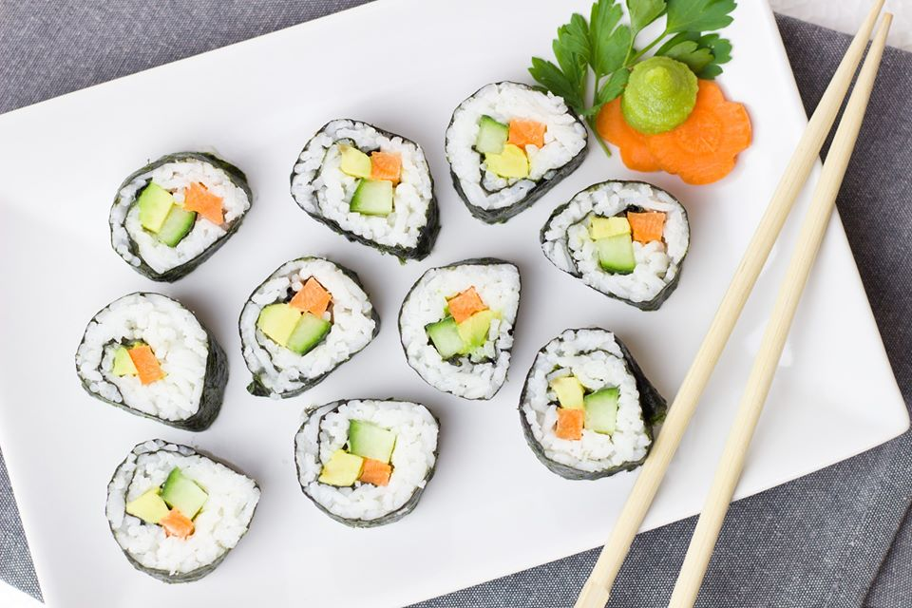

Sushi and California Rolls

Some Terms to Remember  Hoso-maki (Thin rolled sushi)  Futo-maki (Thick rolled sushi)  Makisu (Sushi rolling mat)  Mirin (Japanese rice wine – contains gluten)  Nigiri (Fish sushi)  Nori (Seaweed sheet)  Tamago (egg)  Masago (seasoned salmon roe)  Tobikko (flying fish roe - expensive)  Kombu (dried seaweed used in sushi vinegar)  Surimi (imitation crab sticks - contains gluten)  Dashi (stock)  Shoyu (soy sauce) | Essential Tips  The amount of Sushi vinegar you need to flavor the cooked rice is approximately 20ml of Sushi vinegar for originally 100g of raw rice. So you need 20% of Sushi vinegar in weight of the raw rice. If you cook 500g of raw rice, then you need roughly 100ml of Sushi vinegar to flavor it. It’s important that you pour the Sushi vinegar and mix it with the cooked rice whilst it is still piping hot. You might think it’s sharp when you taste it but do remember that the flavor, or the sourness will mellow down as the rice temperature goes down.  Using a wooden bowl to cool rice down helps as the wood absorbs extra moisture keeping the rice nice and sticky.  The recipes below calls for ½ sheet of nori:½ cup rice for sushi rolls and ½ sheet of nori:¾ cup rice for California rolls, which is difficult to achieve in the beginning. Beginners can increase the size of the nori sheet to ¾ sheet for both recipes for ease. Increase the quantity of the rice to ¾ cup rice:¾ sheet nori for sushi rolls, and almost 1 cup rice:¾ sheet nori for California rolls.

Ingredients
Sushi Rice Ingredients:
-makes about 6-8 rolls

- 2 rice cups or 300g short-grain Japanese rice
- 1/3 cup Sushi Vinegar (contains gluten – please see GF recipe below)

Tamago (Egg) Ingredients:
- 4 eggs
- 1 tablespoon Mirin (may contain gluten – always buy GF mirin)
- 1½ teaspoon GF Soy sauce
- ½ teaspoon Sugar
- pinch salt
- 1-2 tablespoons vegetable oil

Cooking Shitake Mushrooms:
- 4 dried Shitake mushrooms, soaked overnight
- 120ml or ½ cup second dashi stock or 1.5 teaspoons dashi-no-moto mixed with ½ cup water
- 1 tablespoon GF soy sauce (or Shoyu)
- 1.5 teaspoons sugar
- 1 teaspoon mirin

Sushi Roll Ingredients:
- pickled radish, peeled and cut into thin strips (cut into slightly thick strips if making individual rolls)
- carrot, peeled and cut into thin strips
- cucumber, peeled, seeded and cut into thin strips (cut into slightly thick strips if making individual rolls)
- avocado, halved, seeded then wedged using a butter knife
- 4 cooked Shitake mushrooms, cooked as per instructions below
- 4 Asparagus spears, boiled in lightly salted water for 1 minute then cooled
- egg strips (Tamago), cooked and cut into thin strips (cut into slightly thick strips if making individual rolls)
- Nori (roasted seaweed sheets) - halved
- Rolling mat
- Large wooden bowl or large casserole

California Roll Ingredients:
- 1/4 cup toasted black and white sesame seeds (may contain gluten, toast your own sesame for GF option)
- cucumber, peeled, seeded and cut into thin strips
- avocado, halved, seeded then wedged using a butter knife (use immediately)
- imitation crab sticks or snow crab leg meat (thawed and halved into strips - contains gluten)
- Nori (roasted seaweed sheets) - halved
- Rolling mat
- Large wooden bowl or large casserole

To Serve and For Garnish:
- wasabi tube, to serve (may contain gluten – check ingredients)
- soy sauce or GF tamari, to serve
- pickled ginger, to serve
- Kewpie Japanese Mayo, for garnish
- Sriracha sauce, for garnish – optional
- Shichimi Togarashi (red pepper mix), for garnish – optional

Equipment
- Makisu (bamboo rolling mat)
- Plastic wrap
- A bowl of water with 1-2 tablespoons rice vinegar
- Wet and dry towels
- Sharp knives

Making Rice:
- Rinse the rice a few times until water runs clear, then drain in a colander and let dry for 15 minutes.
- Cook the rice in a rice cooker according to the manufacturer's instructions. Alternatively, in a medium saucepan, combine the rice with 2 cups of cold water and bring to a boil over high heat. Cover and cook over moderate heat for 10 minutes. Reduce the heat to low and cook for 10 minutes longer. Remove from the heat and let stand, covered, for 15 minutes.
- Transfer hot rice to a very large wooden bowl. Sprinkle 1/3 cup of sushi vinegar all over the rice: Drizzle onto a spatula while waving the spatula back and forth. Using a slicing motion with the spatula, gently separate the rice grains while mixing in the seasoning. Fan the rice while mixing (if necessary) it to help it dry. Wipe down any stray grains from the side of the bowl. Cover the rice with a damp towel to keep warm.
- When you’re ready, you can begin rolling the rice into sushi rolls.

Making Tamago:
- To make the Tamago, crack eggs, add mirin, soy sauce, salt and sugar and whisk.
- Traditionally this is done in a square pan, but a round one will work. Heat the pan on medium flame. Add oil. Pour a thin layer of egg into the pan. When it is 90% set, start rolling from one side to the other.
- Pour another thin layer of egg and when it is 90% done, roll back to the other side. Continue this process until all the egg has been used.
- Set aside to cool and slice into long strips.

Making Shitake Mushrooms:
- Put the shitake, dashi stock, soy sauce, sugar and mirin in a small pan. Bring to the boil, then reduce heat to low for about 20 minutes until half of the liquid has evaporated.
- Drain and discard stalks. Squeeze out excess liquid from the caps, then slice thinly.

Making Sushi Rolls:
- Place halved nori (roasted seaweed sheet) on the rolling mat. The nori should lay on the rolling mat with the rough side facing upwards.
- Get your hands wet with vinegared water, and roll about 1/2 cup of rice into a ball. When you work with the nori though, you should keep them as dry as you can. That is why you should have a bowl of water (with 1-2 tablespoons rice vinegar added to it) and a dry hand-towel nearby when making sushi.
- Put the rice ball in the middle of the nori sheet, and start spreading it equally on the nori, creating a layer of rice covering almost the entire sheet except the upper margin of about 2 cm that should be kept uncovered. Don’t press too hard as you still want some air in between the grains.
- Lay down the filling closer to the lower edge of the nori. For the filling, you can use individual or any combination of fresh vegetables, egg and/or fish! Our favorite is avocado, egg, and cucumber!
- Using the closer edge of the rolling mat, close on the filling with the nori, tighten it from above. Use your fingers to hold the filling inside and your thumbs to guide the sushi mat over the roll.
- Move forward, continue rolling in, keeping it tight with every move until you reach the end of the nori. Put light pressure at the bottom of the roll, especially on stops to allow it to roll tightly.
- Make sure you tighten the roll moving from the ends to the center. Be careful not to squeeze out the roll filling.

Sushi and California Rolls (Continued)
Making California Roll:
- Make sure your rolling mat is covered in plastic wrap before you start. Place halved nori on the rolling mat with the rough side facing upwards.
- Get your hands wet, and roll about 3/4 cup rice into a ball. When you work with the nori though, you should keep them as dry as you can. That is why you should have a bowl of water (with 1-2 tablespoons rice vinegar added to it) and a dry hand-towel nearby when making sushi.
- Put the rice ball in the middle of the nori sheet, and start spreading it equally on the nori, creating a layer of rice covering the entire sheet. Don’t press too hard as you still want some air in between the grains. Sprinkle all over with toasted sesame seeds and gently flip the sheet and place the rice side down on the mat.
- Lay down the filling just below the center part of the nori. For the filling, use cucumber strips, avocado strips and finally crab sticks on top. Line up the roll closer to you leaving about an inch above the bottom of the mat. (Don’t put too many ingredients or the roll will break open)
- Using the edge (near you) of the rolling mat, close on the filling with the nori using your thumbs to hold the mat and your fingertips to hold the filling in place; gently tighten it from above.
- The mat will now be above the ingredients. Gently press with your fingertips to mould and hold it all together - check at this point to make sure the ingredients are in place. Always make sure the bamboo mat is above the sushi roll and not tucked under at any point.
- Now using your fingers and making sure the bamboo mat is always above the sushi roll, move forward, guide the sushi roll and make the rotation to close it further. Keep pulling on the bamboo mat to give the sushi roll below a few rotations. Make sure you tighten the roll moving from the ends to the center. Be careful not to squeeze out the filling.

Cutting and Serving:
- Clean up the edges by lining the end of the roll with the edge of the mat and tucking the extra ingredients in with your hands.
- Finally, using a clean sharp knife, cut the roll into half and cut each half further into 3-4 pieces. Remember to wipe the knife blade with a wet towel in between cuts and dip the end of the knife in a bowl of water then hold it up and let the water run all the way down the blade to keep the sharp edge lubricated between cuts.
- Place the bamboo mat again on the cut out California roll and press gently to straighten it out (if necessary)

- To serve, separate the pieces to offset them from one another so the inside is clearly visible (or by simply placing them cut side facing up) - serve on a long platter. Serve with a squeeze of wasabi, some soy sauce and pickled ginger on the side. A drizzle of Japanese mayo and a few drops of Sriracha on the side with a light sprinkling of Shichimi Togarashi (red pepper mix) can also be used for garnish.

Quick and Easy Miso Soup
A great way to use leftover seaweed
Serves 2
Ingredients  2 cups chicken broth, or vegetable broth (Typically dashi is used to make miso broth but regular broth works in this quick and easy recipe)  120g silken or firm tofu  1 to 2 medium scallions  2 tablespoons red or white or mixed miso paste (I use mixed organic miso as it’s more versatile and can be used in multiple recipes including marinades, salad dressings and in dumpling fillings too)  Leftover seaweed from sushi, cut into strips - for garnish (optional) | Cooking Instructions  - Prepare the tofu and scallions. Cut the tofu into very small cubes, 1/4-inch to 1/2-inch on each side. Slice the scallions very thinly.  - Bring the broth to a rapid simmer over medium-high heat.  - Place miso paste in a large bowl. Scoop out about 1/2 cup of the broth and pour it over the miso. Whisk with a fork or whisk until the miso is entirely dissolved in the water and no lumps remain.  - Pour the dissolved miso into the simmering broth.  - Reduce the heat to medium-low and add the tofu to the miso. Simmer just enough to warm the tofu, 1 to 2 minutes. Do not boil the miso once the tofu has been added.  - Just before serving, scatter the scallions and some chopped seaweed over the top of the soup.  - Pour the miso into individual bowls and serve. Miso is best when served fresh. It will settle a bit as it sits in the broth; whisk briefly with chopsticks or a spoon to mix the soup again.

Homemade gluten-free sushi vinegar

Ingredients  1/3 cup or 80ml Chinese rice vinegar  2-3 tablespoons sugar  1.5 teaspoons kosher salt (use half if using fine salt) | Cooking Instructions  - Combine rice vinegar, sugar and salt in a small saucepan over medium heat. Whisk until sugar is completely dissolved. Set aside to cool and use.

Nagiri
(should always be consumed fresh)
Ingredients and Cooking Instructions:  1 pack sushi grade salmon or tuna (generally found in the frozen section in supermarkets)  Sushi rice – as made above  - Thaw frozen fish in the refrigerator for up to 24 hours. Pat-dry with a paper towel to remove excess moisture before slicing.  - Thinly slice (diagonally) fish of your choice and add it to your workstation. Make sure you work with a very sharp chef’s knife. Fresh fish is super delicate, and you want to keep it looking silky smooth, with nice, clean edges. Set aside in the fridge until ready to use.  - With wet hands, take a small portion of rice just enough to shape it like a tater tott. Place the thinly sliced fish in your hand at the base of your fingers—and add a small dab of wasabi to the center of the fish. This adds a touch of heat but also helps the fish stick to the rice.  - Next, place the rice on your hand and the sliced fish on top of the rice and press down gently so the fish sits on the rice like the camel’s hump. Serve. | 