Chinese Dumplings
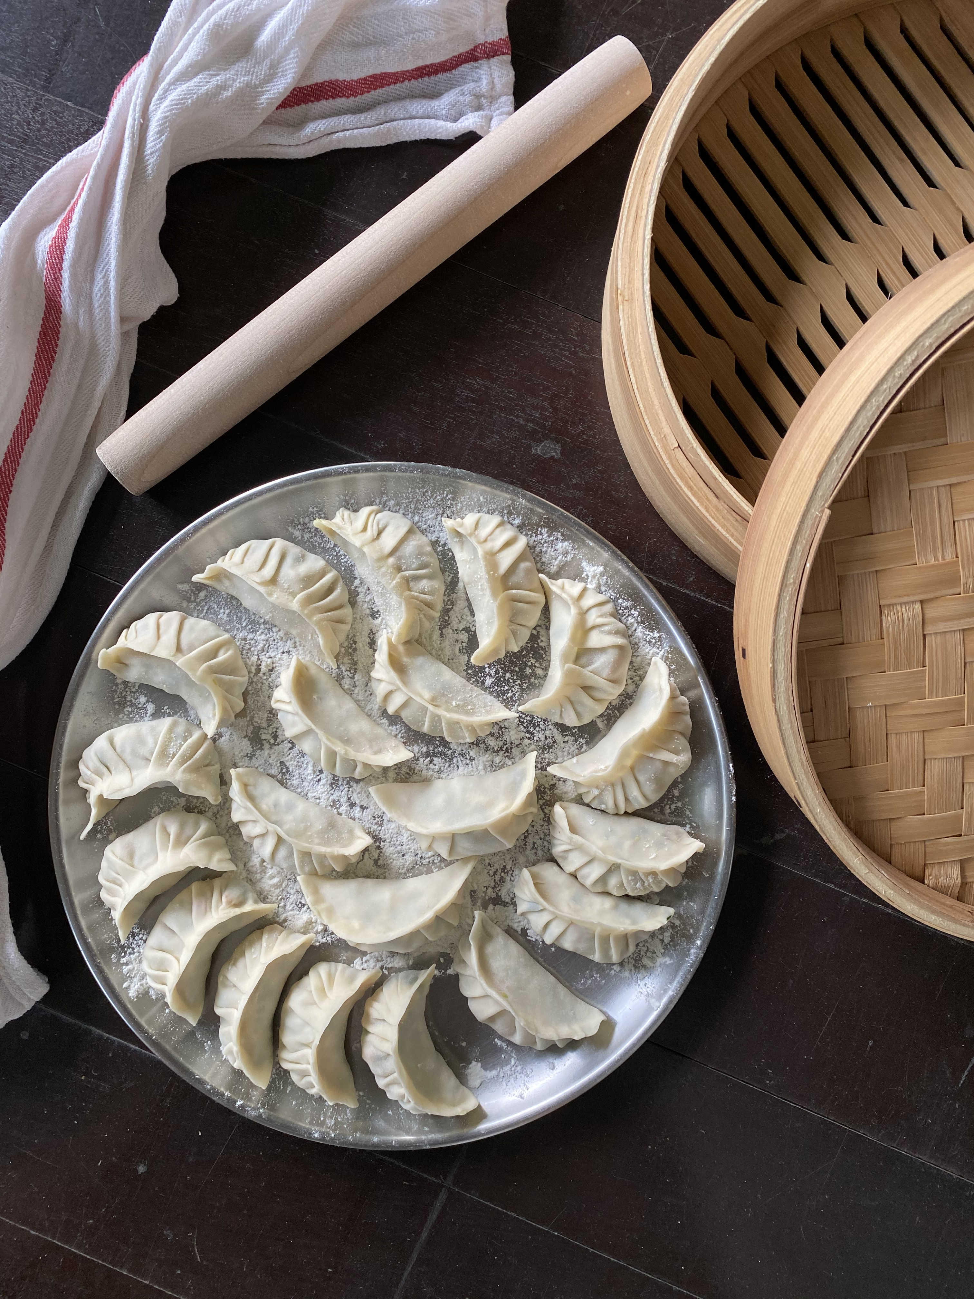

Please note that we will be chopping the ingredients during the class. You can have them chopped and ready if you wish to do so prior to the class. Ingredients have been marked in red on all pages below. Please write to us on info@communekitchen.com or whatsapp us on 88214805 if you have any further questions. We look forward to making dumplings with you this Chinese New Year!

Dumpling Dough
Makes 60 Dumplings
Ingredients  2 packs chilled dumpling pastry (available in the refrigerator section in supermarkets)  3-4 tablespoons vegetable or coconut oil, for frying dumplings  Special equipment:  -Wok  -Non-stick pan w/lid, for frying dumplings  -Bamboo steamer** (available at Sia Huat and kitchen stores in Chinatown– 10” baskets work best)  -Parchment paper liners (buy the same sized liners as your bamboo basket)  -Measuring tablespoons and teaspoons  -Spoons, spatulas and chopsticks  -Knife and chopping board  -Kitchen paper towel  -Tea towels, for covering dumplings  -Medium bowls, for making filling | Filling and Sealing the Dumplings  - Holding the dumpling wrapper in one hand, place a tablespoon of filling in the center of the pastry.  - Dip a finger into some water and lightly moisten the edge of the top half of the circular wrapper.  - Fold the wrapper in half around the filling and pinch the top of the half circle together.  - Continue sealing the edges, either by simply pressing or by using a ruffling technique. (Be sure to pinch the seam tightly to seal the filling inside.)  - Place the shaped dumpling, seam side standing straight up, on a parchment lined platter or in a parchment lined bamboo basket. Keep the dumplings covered with a tea towel at all times.  - Working quickly so that the dumpling wrappers don’t dry out, continue with remaining pastry. (Either freeze or cook your dumplings within 30 minutes of filling, so that the wrappers don’t dry out too much.)  Steaming Dumplings in a Bamboo Steamer  - Pour a few cups of water in a large wok making sure there is at least 2 inches of water in the wok. Cover the wok and bring the water to a hard boil.  - Dumplings (especially frozen dumplings) will stick to the bamboo inside a steamer, so you need to line your bamboo steamer first with breathable parchment paper liners before placing dumplings. Steam the dumplings on full steam until cooked through, about 10 minutes for fresh dumplings and 12 minutes for frozen dumplings.  **Tips on how to wash a new bamboo steamer here - Before using for the first time: Wash all pieces with hot soapy water, rinse well and then soak in hot water for 30 minutes. After soaking, steam all baskets and lid for about 30 minutes (while empty). Allow to fully air dry in the sun before storing. Please note that bamboo steamers are not dishwasher safe.  To Make Pot-stickers from Fresh or Frozen Dumplings  - Heat a tablespoon of oil in a non-stick skillet over medium-high heat.  - Once the oil is hot, place the pot-stickers into the skillet, with the seam side standing straight up, making sure that they are close but not touching.  - Let the pot-stickers sear for 1-2 minutes.  - Add 3 tablespoons of water to the skillet. Cover the pan immediately and reduce the heat to low. Steam the dumplings until all the water has evaporated. The pot-stickers should look opaque and noodle-like, and the filling should be heated through. This will take 5 minutes from fresh or  7-8 min from frozen.  If Freezing the Dumplings for Later  - Arrange your filled, un-cooked dumplings in a single layer on a parchment lined platter or baking sheet, freeze. Once your dumplings have frozen solid in about 2 hours, transfer them into an air-tight Ziploc bag.

Notes: Dumplings will keep in the freezer for up to 3 months

Egg and Chive Filling
30 Dumplings

Ingredients  1 tablespoon vegetable or coconut oil, for scrambling  3 eggs  100g Chinese chives, rinsed and chopped  white pepper, to taste  1 teaspoon sesame oil  1 tablespoon light soy sauce | Cooking Instructions  - On medium flame, heat a tablespoon of oil in a cast iron pan. Whisk together eggs and scramble them in hot oil, set aside.  - Mix together chopped chives, scrambled eggs, and pepper along with sesame oil and soy sauce. Set aside until ready to use.

Chicken or Pork Filling
30 Dumplings

Ingredients  120g Napa cabbage or regular cabbage, finely chopped  1/4 teaspoon salt  1/2 block (150g) smooth Chinese tofu  240g ground/minced chicken thighs or breast (chicken can be replaced with minced pork with 25% fat content – request your butcher)  2 tablespoons light soy sauce  2-3 spring onions, chopped  1 teaspoon grated ginger  1 teaspoon minced garlic  1 tablespoon Shaoxing rice wine (available in the soy sauce section in supermarkets)  1 teaspoon sesame oil  3 dashes ground white pepper | Cooking Instructions  - In a small bowl, place a paper towel at the bottom. Add cabbage, sprinkle 1/4 teaspoon salt and mix – set aside for 10 minutes to draw the water out. Give the cabbage a good squeeze to get rid of any excess water.  - Place tofu on another paper towel and let it drain for 20 minutes.  - Place chicken mince in a large bowl and add soy sauce – mix with chopsticks or using your fingers (only in one direction) for 5-6 minutes until sticky.  - Next add cabbage, chopped spring onion, ginger, garlic, rice wine, sesame oil, and white pepper – stir well. Finally add crumbled tofu, stir gently. This will be the dumpling filling – you can do this step ahead of time if you like.

Dipping Sauce

Ingredients  1/3 cup (80 ml) light soy sauce  2 ½ tablespoons rice vinegar (available in the soy sauce section in supermarkets)  1 teaspoon chili in oil (Lao Gan Ma – available near the soy sauce section in supermarkets) or 1 fresh red bird’s eye chili  2-inch knob young ginger, peeled and cut into matchsticks | Cooking Instructions  - In a small bowl mix all ingredients together. Taste and adjust flavor as needed.

