Gluten-Free Dumplings
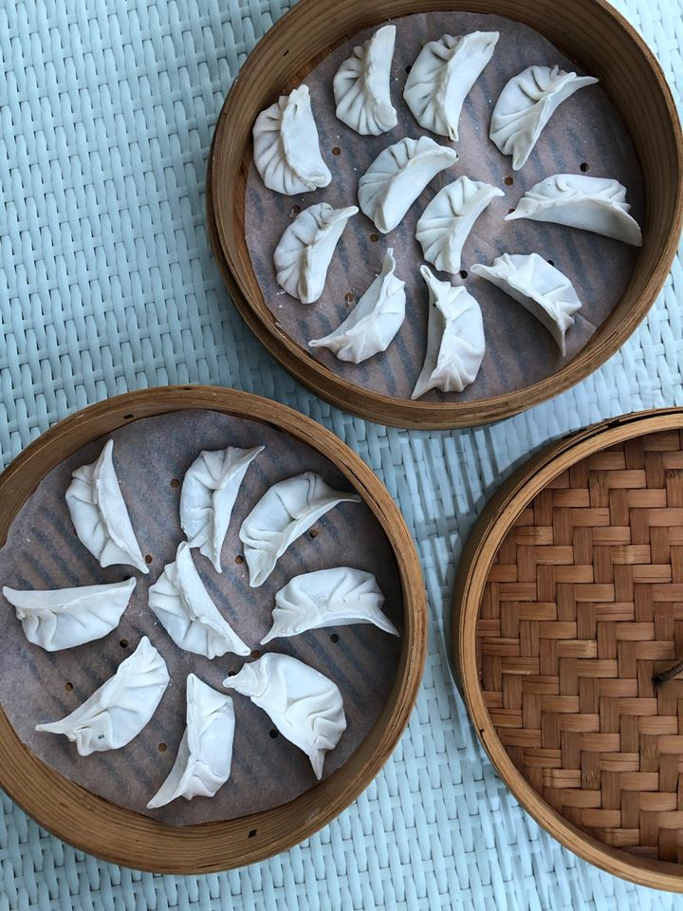

Dumpling Dough
Makes 30 Dumplings
Ingredients  115g finest rice flour (1 cup)  65g tapioca starch (1/2 cup)  2/3 cup + 2 tablespoons boiling hot water (190ml)  2 teaspoons oil  Extra rice flour, for dusting your workspace  Special equipment:  Wok  Bamboo steamer  Parchment paper | Making the Dough  - Place rice flour and tapioca starch in a bowl, adding boiling water last. Mix quickly, using chopsticks or a spoon, until the mixture starts to come together.  - In about a minute when the dough is cool enough to handle, knead using your dominant hand until the dough forms a smooth ball.  - Add 2 teaspoons oil and knead for 2-3 more minutes until smooth. Use as below.  Rolling the Dumpling Wrappers  - Roll the dough into a long log and cut into even pieces (should be around 10-12g each). Dust lightly with rice flour and flatten each piece with your palm to form discs; place them on a lightly floured surface. Cover the discs with a damp tea towel at all times.  - Keeping what you are not working with covered, dust each disc with rice flour and gently roll into a thin circle roughly 8cm in diameter.  Filling and Sealing the Dumplings  - Holding the dumpling wrapper in one hand, place a tablespoon of filling in the center of the rolled-out round of dough.  - If your wrapper seems dry, dip a finger into some water and lightly moisten the edge of the top half of the circular wrapper.  - Fold the wrapper in half around the filling and pinch the top of the half circle together.  - Continue sealing the edges, either by simply pressing or by using a ruffling technique. (Be sure to pinch the seam tightly to seal the filling inside.)  - Place the shaped dumpling, seam side standing straight up, on a parchment lined platter. Keep the dumplings covered with a tea towel at all times.  - Working quickly so that the dumpling wrappers don’t dry out, continue with remaining pastry. (Either freeze or cook your dumplings within 30 minutes of filling, so that the wrappers don’t dry out too much.)  Continued…  Steaming Dumplings in a Bamboo Steamer  - Pour a few cups of water in a large wok making sure there is at least 2 inches of water in the wok. Cover the wok and bring the water to a hard boil.  - Dumplings (especially frozen dumplings) will stick to the bamboo inside a steamer, so you need to line your bamboo steamer first. You can use parchment paper with holes made in it to make a breathable non-stick surface. Place your dumplings, then set the steamer on top of the wok full of boiling water. Steam the dumplings on full steam until cooked through, about 8 minutes for fresh dumplings and 11-12 minutes for frozen dumplings.  If Freezing the Dumplings for Later  - Arrange your filled, un-cooked dumplings in a single layer on a parchment lined platter or baking sheet, freeze. Once your dumplings have frozen solid in about 2 hours, transfer them into an air-tight Ziploc bag.

Notes: Dumplings will keep in the freezer for up to 3 months

Spinach and Tofu Filling
30 Dumplings

Ingredients  250g Chinese spinach, discard roots and most part of the stems and rinse well  4 large dried shitake mushrooms, soak overnight in water  1/4 teaspoon salt  1/4 teaspoon ground white pepper  3/4 teaspoon sugar  1 1/2 tablespoons GF soy sauce  1 tablespoon sesame oil  1 tablespoons vegetable oil  1 tablespoon finely minced fresh ginger  1/3 cup finely chopped carrot  90g firm tofu (Tau Kwa), finely chopped  2 teaspoons cornstarch dissolved in 1 tablespoon water  1/2 cup chopped Chinese chives or scallions (white and green parts) | Cooking Instructions  - To make the filling, bring about 1.5 L water to a boil, Add spinach and let it wilt for about 60 seconds, drain, rinse with cold water, and drain again to retain color. To remove excess moisture, squeeze the spinach in your hands over the sink. When you are done, there should be about 1/2 cup firmly packed spinach. Chop coarsely on a chopping board, set aside.  - In a bowl, rinse and soak dried shitake mushrooms overnight in 2 cups water. Once soaked, reserve soaking liquid, squeeze excess water out from mushrooms and stem them, then chop finely.  - Combine 1/4 cup of the reserved mushroom soaking liquid, salt, white pepper, sugar, soy sauce, and sesame oil. Stir to dissolve the sugar. Set this flavoring sauce aside.  - In a wok or large skillet, heat vegetable oil over medium heat. Add the ginger and stir-fry for about 30 seconds, until aromatic. Add the spinach, carrot, mushrooms, and tofu. Stir to combine and then pour in the flavoring sauce. At first, all the liquid will seem to have been absorbed, but after 2 minutes, there will be a little bubbling liquid in the skillet. At that point, give the cornstarch mixture a final stir and stir it into the filling. When the mixture thickens, turn off the heat and add the Chinese chives. Transfer to a bowl and set aside to cool completely before assembling the dumplings. You should have about 2 cups of filling. (The filling can be prepared 1 day in advance and refrigerated. Bring it to room temperature before assembling the dumplings.)

Prawn Filling
30 dumplings

Ingredients  250g peeled, deveined prawns, roughly minced  50g bamboo shoots (diced)  50g water chestnuts (diced) - each peeled chestnut weighs about 15-20g  2-3 spring onions (finely sliced)  1 tablespoon GF light soy sauce  1 teaspoon dry sherry OR 1 teaspoon white wine  1 teaspoon sesame oil  1/2 egg white  Salt and white pepper, to season  1 teaspoon of potato starch (or corn starch) | Cooking Instructions  - Place prawn mince in a bowl; add soy sauce then stir with chopsticks or a spoon (only in one direction) for 5-6 minutes until sticky.  - Add the bamboo shoots, water chestnuts and spring onion to the prawns.  - Mix and then add the sherry (or white wine), sesame oil, egg white, potato starch, and season with a generous pinch of salt, and white pepper. Stir well.  - Cover with cling film and leave in the fridge for at least 30 minutes before making dumplings.

Egg and Chive Filling (Try this at home!)
30 Dumplings

Ingredients  1 tablespoon vegetable or coconut oil, for scrambling  3 eggs  1 bunch Chinese chives (100g), chopped  white pepper, to taste  1 teaspoon sesame oil  1 tablespoon GF light soy sauce | Cooking Instructions  - On medium flame, heat a tablespoon of oil in a cast iron pan. Whisk together eggs and scramble them in hot oil, set aside.  - Mix together chopped chives, scrambled eggs, and pepper along with sesame oil and soy sauce. Set aside until ready to use.

Chicken or Pork Filling
30 Dumplings

Ingredients  120g Napa cabbage, finely chopped  1/4 teaspoon salt  1/2 block (150g) smooth Chinese tofu  240g ground chicken thighs (chicken can be replaced with minced pork with 25% fat content)  2 tablespoons GF light soy sauce  2-3 spring onions, chopped  1 teaspoon grated ginger  1 teaspoon minced garlic  1 tablespoon dry sherry or white wine  1 teaspoon sesame oil  3 dashes ground white pepper | Cooking Instructions  - In a small bowl, place a paper towel at the bottom. Add Napa cabbage, sprinkle 1/4 teaspoon salt and mix – set aside for 10 minutes to draw the water out. Give the cabbage a good squeeze to get rid of any excess water.  - Place tofu on another paper towel and let it drain for 20 minutes.  - Place chicken mince in a large bowl and add soy sauce – mix with chopsticks or using your fingers (only in one direction) for 5-6 minutes until sticky.  - Next add cabbage, chopped spring onion, ginger, garlic, wine, sesame oil, and white pepper – stir well. Finally add crumbled tofu, stir gently. This will be the dumpling filling – you can do this step ahead of time if you like.

Dipping Sauce

Ingredients  1/3 cup (80 ml) GF light soy sauce  2 ½ tablespoons rice vinegar  1 teaspoon pure chili oil or 1 finely chopped red chili padi  2-inch knob young ginger, peeled and cut into matchsticks | Cooking Instructions  - In a small bowl mix all ingredients together. Taste and adjust flavor as needed.

