Chicken Xiao Long Bao
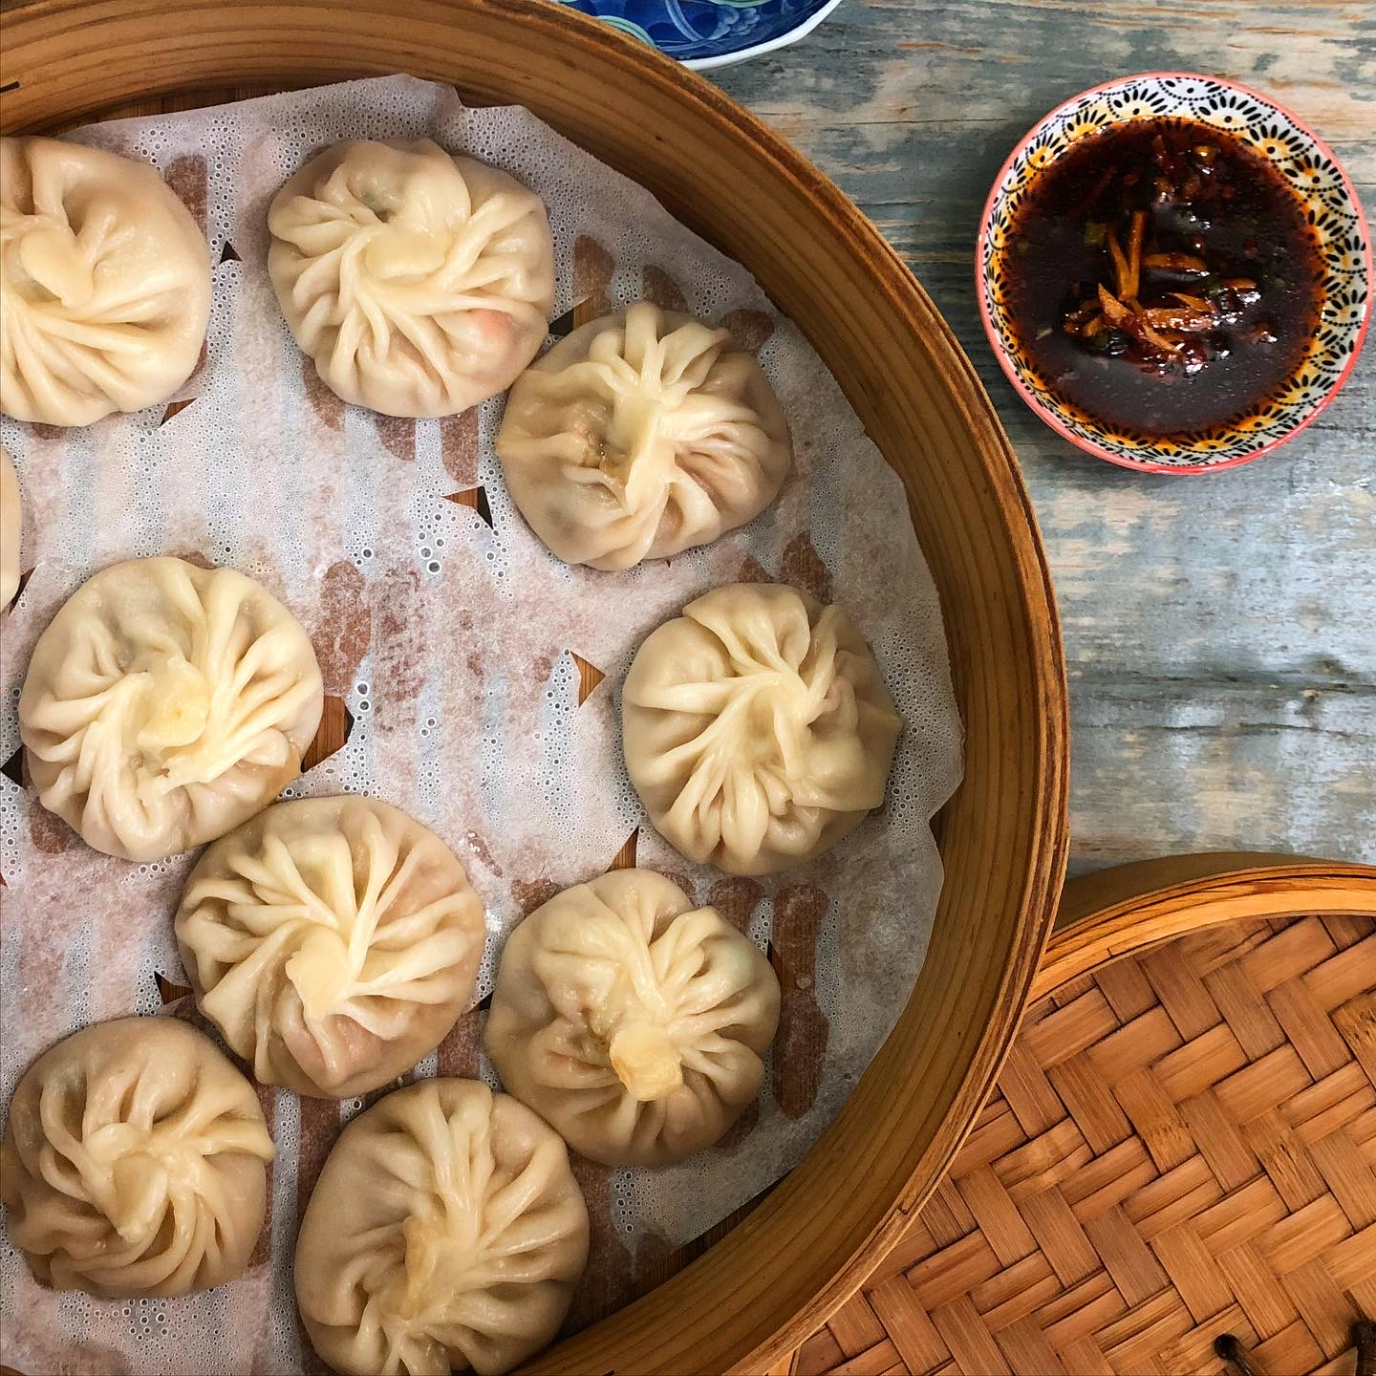

Chicken Xiao Long Bao
Makes 25-30 Dumplings
Ingredients  FOR THE JELLY  1 whole chicken, cut into pieces  4-5 slices ginger  1 bunch spring onion  3 bay leaves  ½ teaspoon Sichuan peppercorn  ½ teaspoon fennel seeds  1 star anise  ¾ teaspoon sea-salt  ¾ teaspoon sugar  ¾ teaspoon white pepper  2 tablespoons gelatin (halal)  FOR THE PASTRY  2 cups or 250g unbleached all-purpose flour or high protein flour  1/2 teaspoon salt  ¾ cup (180ml) hot water  SAUCE  1/8 cup spring onion bulbs  4 slices ginger  3 tablespoons water  FOR THE FILLING  300g minced chicken thighs  400ml chicken jelly, chopped  2-3 chopped spring onion  1/4 cup minced carrot or water chestnuts  1/4 cup minced cabbage  1 teaspoon cornstarch  1 teaspoon dark soy sauce  1 teaspoon white sugar  1 teaspoon sesame oil  1/2 teaspoon salt or to taste  1/4 teaspoon ground white pepper  1 teaspoon Sichuan pepper, lightly toasted and ground  Cooking Instructions Continued  - Roll each piece into a 1-inch diameter log (roughly 8 inches long). Let the dough logs rest on a lightly floured surface, covered with a damp tea towel for 30 minutes while you prepare your filling.  MAKING THE FILLING (enough to make 25-30 dumplings)  - You can do this once the the jelly is done setting in the fridge.  - Use spring onion bulbs and ginger to make a sauce. Place them in a tall cup with 3 tablespoons water and blend well using a hand-blender until smooth. Strain the sauce into a bowl.  - Pour the sauce into the ground chicken. Stir well.  - In a large mixing bowl place minced chicken, and salt. Stir well in one direction for about 6 minutes until sticky.  - Add spring onion leaves, carrot, cabbage, cornstarch, white sugar, dark soy sauce, sesame oil, salt, white pepper, and Sichuan pepper into the meat, stir.  - Last step is to mix it well with the finely chopped minced jelly. Set it aside in the refrigerator.  CLOSE THE DUMPLINGS (This is the most important step to make your dumplings look great.)  - Cut each one log into roughly 3⁄4 inch pieces (about 10-12g each). Roll each piece into a ball. To roll the dumpling wrappers, dust your countertop lightly with flour. | Cooking Instructions  MAKING THE JELLY  - Remove any visible fat from chicken. Wash the chicken bones and skin thoroughly and add them into a pot of boiling water. Boil for 2-3 minutes, turn off the heat and drain immediately. Drain and rinse the bones under tap water, to get rid of impurities.  - Fill a pot with 1.2L water, ginger, spring onions, bay leaves, Sichuan peppers, fennel seeds, star anise, and chicken. Season with salt, sugar, and pepper, stir well. Bring to a boil. Simmer over low-medium heat until liquid has reduced to almost 400-500ml, about 2 hours.  - Using a colander, strain stock back into the saucepan. Skim and discard any fatty oils on the surface. Separate solids (you may shred chicken off the bones and use it for another recipe or simply serve it hot with some dipping sauce. I shred mine and mix with stir-fried noodles. Recipe link here, https://www.communekitchen.com/stir-fried-udon-noodles-recipe.html)  - Place gelatin in a bowl with a few tablespoons hot stock, stir to dissolve. Pour gelatin mix into hot stock and stir well. Place in a container, let the liquid cool down, cover and refrigerate. Refrigerate for at least 6 hours to set to the jelly. Once set, the jelly is ready for use; jelly can be stored in the fridge for up to 3 days.  - Carefully mince cold jelly using a chopping board and chef’s knife; try not to touch it with your hands to avoid melting. Make sure there are no big chunks. Use it immediately.  MAKE THE DUMPLING WRAPS  - Place the flour and salt in a medium bowl. Add the water, a little at a time, mixing constantly first with chopsticks and then with your hands until stiff dough comes together.  - Knead the dough until it is smooth, 8-10 min. (This kneading step is important, it helps develop tender dumpling wrappers)  - Put the kneaded dough into a clean bowl and cover it with a damp towel. Let the dough rest in a warm place for 30 minutes. Knead it again for a few minutes and let it rest again for another half an hour.  - Once rested, knead the dough again for 3-5 min and cut it into two, roughly even pieces.  - Keeping what you are not working with covered, roll one ball at a time into a thin disc roughly 8-10cm in diameter. Thin out the edges.  - Take a wrap and put enough meat so it’s almost full. I put a little bit more than a tablespoon.  - Lift one part of the edge and pinch it to make a pleat. Continue all the way around.  - At the end, pinch it together to close the dumpling.  FREEZING DUMPLINGS FOR LATER  - Arrange your filled, un-cooked dumplings in a single layer on a parchment-lined tray or baking sheet, freeze. Once your dumplings have frozen solid in about 2 hours, transfer them to an airtight container or Ziploc bag. Frozen dumplings keep well for up to 3 months.  - To steam, place frozen dumplings in a bamboo steamer lined with parchment paper (with holes) and steam for 9-10 minutes. Serve hot.  STEAM  (You should do this as soon as possible after closing the dumpling)  - Put parchment paper (with holes for steam to escape) in a large bamboo steamer.  - Leave some space between the dumplings.  - In a large wok bring a few inches of water to a boil, then put the steamer in and let it steam it for 7-8 minutes on high heat. Serve hot.  FOR THE DIPPING SAUCE  some shredded fresh ginger  4 tablespoons white vinegar or Ching Kiang black vinegar  4 teaspoons soy sauce  1 teaspoon chili oil  - Mix together dipping sauce ingredients. Serve with steamed Xiao Long Bao.

Notes: Normally, each dumpling can have up to 18-22 pleats in total. As a beginner, you can start with 10-12 pleats. Place folded dumplings on a tray lined with parchment paper (or dusted with flour) and cover with a tea towel while folding more dumplings. Always make Xiao Long Bao in an air-conditioned room as the jelly will start to melt in hot weather. Either use the dumplings within 30 minutes of making them or place them in the freezer.

To make quick and easy chicken stock jelly:
400ml store-bought chicken stock
2 tablespoons gelatin powder (use double the amount mentioned on your gelatin pack as you require thick jelly for the above recipe)

Bring chicken stock to a boil. Dissolve gelatin in a few tablespoons of hot stock. Pour it into the rest of the stock. Mix well using a whisk. Place it in a glass container, let it cool, cover, and refrigerate for about 6 hours until solid. Use as above.

