Baos & Paos
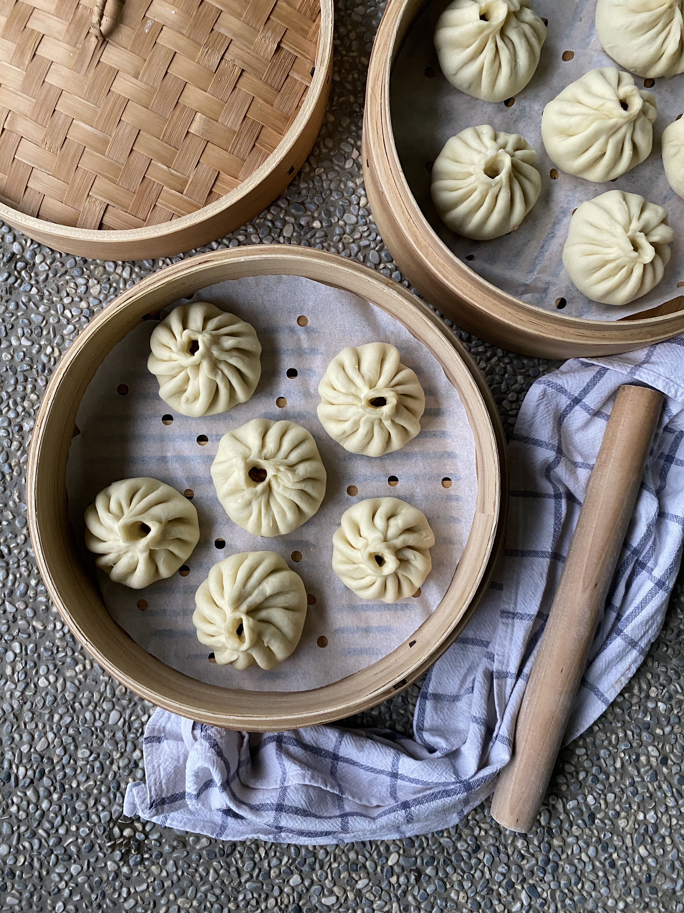

**Tips on how to wash a new bamboo steamer here - Before using for the first time: Wash all pieces with hot soapy water, rinse well and then soak in hot water for 30 minutes. After soaking, steam all baskets and lid for about 30 minutes (while empty). Allow to fully air dry before storing. These are not dishwasher safe.

Pork Baozi
Makes 12-14
Ingredients  For the dough  2 cups all-purpose flour (300 grams)  2 tablespoons cornstarch (20 grams)  1 teaspoon instant yeast (3 grams)  1 tablespoon sugar (granulated, 15 grams)  ¼ teaspoon salt  ⅛ teaspoon baking soda  1 tablespoon vegetable oil  ¾ cup (160g) warm water  For the filling  150 g fatty minced pork (with about 25% finely minced fat)  2 teaspoons light soy sauce  1 teaspoon dark soy sauce  1 teaspoon oyster sauce  1 clove garlic, minced  1 teaspoon sesame oil  1/4 teaspoon salt  1/2 teaspoon sugar  1 pinch toasted ground Sichuan pepper or Chinese five-spice powder  4 tablespoon unsalted chicken stock  1 tablespoon cooking oil  150 g carrot, finely chopped  75g onion, peeled and finely chopped  2-3 finely chopped spring onion or 1/3 cup finely chopped Chinese chives | Cooking Instructions  Prepare the dough  - Mix flour, cornstarch, yeast, sugar, salt, baking soda and oil in a bowl. Pour in water gradually while mixing. Combine and knead with your hands until a very smooth dough comes together.  - Cover the bowl with a damp tea towel and leave it to rise in a warm place until double in size (It may take between 40 minutes to 1.5 hours depending on the room’s temperature).  Make the filling  - Place minced pork, light and dark soy sauce, oyster sauce, garlic, sesame oil, salt, sugar, and Sichuan pepper/Chinese five-spice in a mixing bowl.  - Using chopsticks mix constantly in one direction while gradually adding water/stock until all the liquid is well incorporated in the mince.  - Stir-fry grated carrot and onion in a tablespoon of hot oil until softened - let it cool. Add to the pork along with chopped spring onion. Split into 12 equal portions.  Shape the buns  - Punch down the dough and knead until it is super smooth inside with very few air bubbles left inside. This will ensure even rising of buns during the second proof.  - Roll into an even log and then cut it into 14 equal portions. Roll each piece into a disk-like wrapper about 10cm in diameter, making sure the edges are thinner than the center.  Pork Baozi continued…  - Place about 2 tablespoons filling in the middle of a wrapper then pleat into a bao shape. Hold the bun on your left hand, hold a corner of the edge between the index finger and thumb of your right hand. Create pleats using your left hand and pinch them using your right hand. Continue doing this all the way around. One important note is that your thumb never leaves the first pleat. In the end, you twist and seal to create a tiny hole on top for steam to rise.  - Leave all the assembled buns to rest for another 15 minutes in a parchment-lined bamboo steamer. Leave about 2cm of space in between the buns and from the walls of the steamer, to give the buns room to expand.  Steam the buns  - Place the buns inside the steamer starting with cold water over high heat. Turn the heat down to medium-low when the water starts boiling.  - Cook for about 15 minutes. Turn off the heat, then open the lid ever so slightly and let the steam out for a few minutes before serving. This will ensure the buns don’t shrink due to sudden change in temperature.  - Serve them warm with chili oil.  Storage & reheat  - You can freeze cooked buns. Thaw frozen buns in the fridge then steam for 8 minutes to warm up, or steam for 15 minutes without defrosting.

NOTES:
Making ground Sichuan pepper powder
Place Sichuan peppercorns in a cold frying pan. Roast over medium-low heat for a few minutes until aromatic. Look out for the signs of readiness:
- They start to release their aroma.
- They look a little oily on the surface
Remove them from the hot pan immediately. Over-roasting will make them bitter.

Leave the roasted peppercorns to cool before you grind them. I use my mortar and pestle to do the job. After the roasting and cooling process, the peppercorns become brittle thus very easy to grind. You may also use an electric grinder if you wish.

Finally, sift the crushed pepper through a fine-mesh sieve. This is to remove the gritty, sandy bits (from the black seeds and/or the yellow inner parts of the husks). I strongly advise you not to skip this step.

Sichuan pepper’s aroma and numbing effect decreases over time particularly after grinding, therefore grind a small amount at a time.

Keep freshly ground Sichuan pepper in airtight containers away from heat & direct sunlight. Use it within two weeks for optimal flavor.

Vegetarian Baozi
Makes 12-14
Ingredients  For the dough  2 cups all-purpose flour (300 grams)  2 tablespoons cornstarch (20 grams)  1 teaspoon instant yeast (3 grams)  1 tablespoon sugar (granulated, 15 grams)  ¼ teaspoon salt  ⅛ teaspoon baking soda  1 tablespoon vegetable oil  ¾ cup (160g) warm water  For the filling  400g baby bok choy, thoroughly washed  8 dried shitake mushrooms, rehydrated  1-2 tablespoons light olive oil or vegetable oil  1 tablespoon grated ginger  115g tau kwa (firm tofu)  1 teaspoon light soy sauce  ½ teaspoon sugar  1 tablespoon dou ban jiang (spicy hot bean paste), optional  1 block fermented tofu, crushed  1/8 teaspoon ground white pepper  1 teaspoon cornstarch  ½ tablespoon sesame oil  Salt, to taste | Cooking Instructions  Prepare the dough  - Mix flour, cornstarch, yeast, sugar, salt, baking soda and oil in a bowl. Pour in water gradually while mixing. Combine and knead with your hands until a very smooth dough comes together.  - Cover the bowl with a damp tea towel and leave it to rise in a warm place until double in size (It may take between 40 minutes to 1.5 hours depending on the room’s temperature).  Make the filling  - Rinse and soak dried shitake mushrooms overnight in room temperature water.  - Prepare a pot of boiling water. Blanch the bok choy for a quick 30 seconds, drain and rinse with cold water to cool it down. Squeeze as much water as possible from the bok choy. This step is very important to prevent soggy buns.  - Next, finely chop the bok choy and transfer into a mixing bowl.  - Squeeze excess water out of mushrooms, discard stems and chop the mushrooms finely.  - On medium flame, heat oil in a wok. Add grated ginger followed by chopped bok choy, and mushrooms. Cook for 2-3 minutes, then add tofu, light soy sauce, sugar, doubanjiang, fermented tofu and a sprinkle of ground white pepper – stir well.  - Add a tablespoon of water to a teaspoon of cornstarch – stir well, then add the slurry to the wok. Stir well and let sauce thicken .  - Finally, add sesame oil and salt to taste. Stir well and set aside to cool.  Shape the buns  - Punch down the dough and knead until it is super smooth inside with very few air bubbles left inside. This will ensure even rising of buns during the second proof.  - Roll into an even log and then cut it into 14 equal portions. Roll each piece into a disk-like wrapper about 10cm in diameter, making sure the edges are thinner than the center.  - Place about 2 heaping tablespoons filling in the middle of a wrapper then pleat into a bao shape. Hold the bun on your left hand, hold a corner of the edge between the index finger and thumb of your right hand. Create pleats using your left hand and pinch them using your right hand. Continue doing this all the way around. One important note is that your thumb never leaves the first pleat. In the end, you twist and seal to create a tiny hole on top for steam to rise.  - Leave all the assembled buns to rest for another 15 minutes in a parchment-lined bamboo steamer. Leave about 2cm of space in between the buns and from the walls of the steamer, to give the buns room to expand.  Steam the buns  - Place the buns inside the steamer starting with cold water over high heat. Turn the heat down to medium-low when the water starts boiling.  - Cook for about 15 minutes. Turn off the heat, then open the lid ever so slightly and let the steam out for a few minutes before serving. This will ensure the buns don’t shrink due to sudden change in temperature.  - Serve them warm with chili oil.  Storage & reheat  - You can freeze cooked buns. Thaw frozen buns in the fridge then steam for 8 minutes to warm up, or steam for 15 minutes without defrosting.

Homemade Chili Oil
Makes 1.5 cups

Ingredients  Group 1: For the chili  ¼ cup chili flakes  1 tablespoon chili powder  ½ tsp salt  2 tablespoons toasted sesame seeds  Group 2: For the oil  1½ cup vegetable oil  1 teaspoon Sichuan peppercorns  1 teaspoon fennel seeds  1 star anise  1 piece Chinese cinnamon/cassia cinnamon  1 bay leaf  1 Tsao-ko/Chinese black cardamom, optional  3 slices ginger  2 stalks spring onion bulbs | Cooking Instructions  - In a bowl, mix all the ingredients in Group 1. Have another empty glass bowl ready. The bowl should be deep, heat proof and completely dry. Place a sieve over it.  - Heat oil into a cold wok/saucepan, reduce heat to low then add all the ingredients in Group 2. Cook over low heat. Watch attentively. Turn off the heat immediately when the spring onion turns brown.  - Pour the oil into the empty glass bowl through the sieve. Discard everything caught in the sieve.  - Add half of the chili mixture into the hot oil. You should see it bubbling intensively. Add the remaining when bubbling calms down. Stir well with a clean dry spoon.  - Leave to cool uncovered, then transfer into an air-tight container of your choice and refrigerate for up to 6 months. Wait for at least 12 hours before using to allow all the flavors to mingle.  A simple version  - You can reduce the ingredient list to four essentials: chili flakes, sesame seeds, ginger and oil. Try the complete version whenever you have a chance. It is truly worth the effort!  After a while, the cooked chili flakes and sesame seeds tend to settle at the bottom of the container. Use a clean spoon to stir before serving.  If your dish requires pure chili oil, use a sieve to filter out the chili flakes and sesame seeds.

